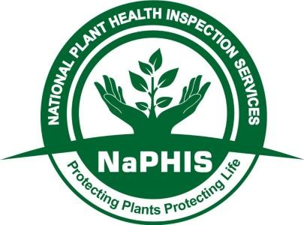

The template of the National Plant Protection Organization of South Africa (NPPOZA) for the purpose of registration of PUC, PHC (fresh produce/plant products) by trading partners when they intend to export into SA.

NB: The lists/registered databases should be provided to NPPOZA, 4 weeks prior to the export season. No permit will be issued in the event where a lists/database is not provided, a surveillance report to be provided where required by the agreed protocol/workplan.

Table 1:Production Unit Code (PUC)

PUC/ Registration No.  SD 0032 | Name of Production Unit/Farm  Nisela Farms – Kubuta  -26.878333,  31.506404 | Type of Commodity  Green Banana | Name of Variety/cultivar  Williams, Grand Nain, Apollo, Asdia | Production Area (Ha)  120 | Estimate Volume (tons)  6000 | Province  Eswatini | District  Shiselweni | Name of Storage/ Treatment facility (where applicable)  N/A

Table 2: Packhouse code (PHC)

PHC/ Registration No  SD 0033 | Name of Packhouse /Organization  Nisela Farms – Kubuta  -26.878333,  31.506404 | Packhouse/Facility Manager and Contacts  Dumisa Sikhondze  +268 78025894 | Province  Eswatini | District  Shiselweni

Note:
The PUC and PHC list must contain atleast the above minimum information, respectively.
Kindly include GPS coordinates
Kindly ensure the lists are on an official country/organisation/department template, signed and dated by the responsible/delegated officer. If the list is in Excel, the attached file must be accompanied by a signed letter.

