SAMIC Contacts:

EXECUTIVE DIRECTOR

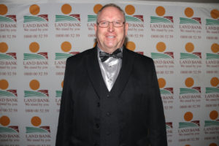

Rudi van der Westhuizen
Po Box 36802
Menlo Park
0102
Tel: 012 361 4545
Fax: 012 361 9837
Cell: 082 900 3005
Email: rudivdw@samic.co.za

PERSONAL ASSISTANT TO THE EXECUTIVE DIRECTOR

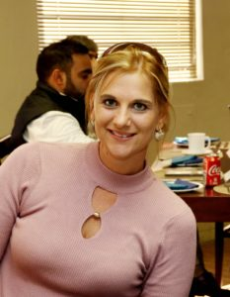<img src="http://samic.co.za/wp- vw, 233px" />

Orpa Thirion
Po Box 36802
Menlo Park
0102
Tel: 012 361 4545
Fax: 012 361 9837
Email: rudivdw@samic.co.za

DEPUTY TECHNICAL MANAGER/DEPUTY DIRECTOR

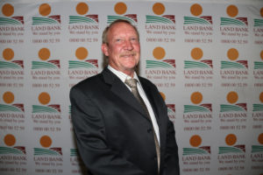<img src="http://samic.co.za/wp-content/uploads/2019/09/Hennie-Gerber-300x200.jpg" width="300" height="200" alt="" Hennie Gerber
Cell: 082 901 6385
Fax: 011 696 1525
E-mail: hennie@samic.co.za

REGIONAL MANAGER

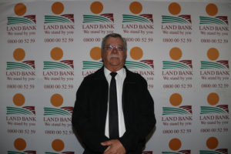< con

Dirk Zandberg
Cell: 082 900 3026
Fax: 086 680 7109
E-mail: dirkz@samic.co.za

QC / TECHNICAL MANAGER

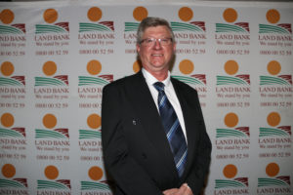<img src="http://samic.co.za/wp-content/uploads/2019/09/Neels-Nell-300x200.jpg" width="300" height="

Neels Nell
Po Box 36802
Menlo Park
0102
Tel: 012 361 4545
Fax: 012 361 9837
Cell: 082 900 3022
Email: neelsn@samic.co.za

CLASSIQUIP DEBIT /CREDIT CONTROLLER

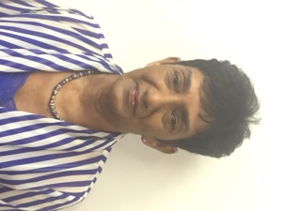

Patti Kistan
Po Box 36802
Menlo Park
0102
Tel: 012 361 4545
Fax: 012 361 9837
Email: pattik@samic.co.za
Sole trader of classifying roller mark equipment sold to abattoirs classifying in South Africa.

NATIONAL MANAGER TRANSFORMATION



Chris Ngeleza
Cell: 082 941 0688
Fax: 086 643 1354
E-mail: chrisn@samic.co.za

NATIONAL MANAGER HIDES AND SKINS AUDIT COORDINATOR & MOHAIR

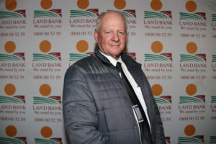<

Steve van Schoor
Cell: 082 900 3037
Fax: 086 557 0746
E-mail: steve@samic.co.za

