DRAFT

DEPARTMENT OF AGRICULTURE
NO. 2026

AGRICULTURAL PRODUCT STANDARDS ACT, 1990 (ACT No. 119 OF 1990)

REGISTRATION OF “ROOIBOS”/”RED BUSH” AS A SOUTH AFRICAN
GEOGRAPHICAL INDICATION (GI)

It is hereby made known that the Executive Officer: Agricultural Product Standards has registered “Rooibos”/” Red Bush” as a South African Geographical Indication (‘GI’) in terms of the “Regulations relating to the protection of Geographical Indications and Designations of Origin used on Agricultural Products intended for sale in the Republic of South Africa” (‘The GI and Designation of Origin Regulations’) as published under No.R.3023 in Government Gazette no. 48015 of 10 February 2023.

Further made known is that the Executive Officer: Agricultural Product Standards in terms of the GI and Designation of Origin Regulations hereby inserts after regulation 24, the following Annexure of “The Applicable Minimum Product Specifications for the Registered South African GI ‘Rooibos’ / ‘Red Bush’ ”.

ANNEXURE B

THE APPLICABLE MINIMUM PRODUCT SPECIFICATIONS FOR THE REGISTERED
SOUTH AFRICAN GI “ROOIBOS”/“RED BUSH”

- Type of Agricultural Product

“Rooibos”/“Red Bush” is the oxidised or green (unoxidised) dried leaves and stems of Aspalathus linearis regulated in terms of sections 3(1), 4(1) and 15 of the Agricultural Product Standards Act (Act 119 of 1990).

- Descriptions of the characteristics of “ROOIBOS”/”RED BUSH”

2.1 Minimum Requirements for the product

The name of “Rooibos”/”Red Bush” refer to the dried leaves and stems of 100% pure rooibos derived from Aspalathus linearis and that has been cultivated or wild-harvested in the geographic area as described in this application.

“Rooibos”/“Red Bush” is presented in two forms: a) oxidised and b) green (unoxidised) dried leaves and stems of Aspalathus linearis.

- In the case of oxidised dried leaves and stems of Aspalathus linearis, “Rooibos”/“Red Bush” has a distinctive colour that ranges from light brown, yellow to a shiny brick-red colour. It may also have some lighter coloured sticks (dried pieces of stem) mixed with the rest of the product. The moisture level of oxidised “Rooibos”/“Red Bush” is below 10%.

- Green (unoxdised) “Rooibos”/“Red Bush” is the unoxidised dried leaves and stems of the Aspalathus linearis plant and its leaves have a dominant light green colour whilst it includes reddish brown thin stem and white woody pieces. Any sign of browning or oxidation is absent from green (unoxidised) “Rooibos”/ “Red Bush”. The moisture level of green (unoxidised) “Rooibos”/“Red Bush” is below 5%.

- “Rooibos”/“Red Bush” derives its name from the natural, red colour of the tea leaves when dried in the sun, brought about by naturally occurring enzymes that oxidise the plant material.

2.2 Designated geographical area

The geographical area of production, drying and oxidation of “Rooibos”/“Red Bush” must fall within the winter rainfall area of South Africa as well as within the fynbos biome (Figure 1). The most significant “Rooibos”/”Red Bush” production area is in the Western Cape Province with a smaller production area in the Northern Cape Province of South Africa.
Figure 1: The intersect between the fynbos biome and the winter rainfall area in South Africa
(Source: Western Cape Department of Agriculture)

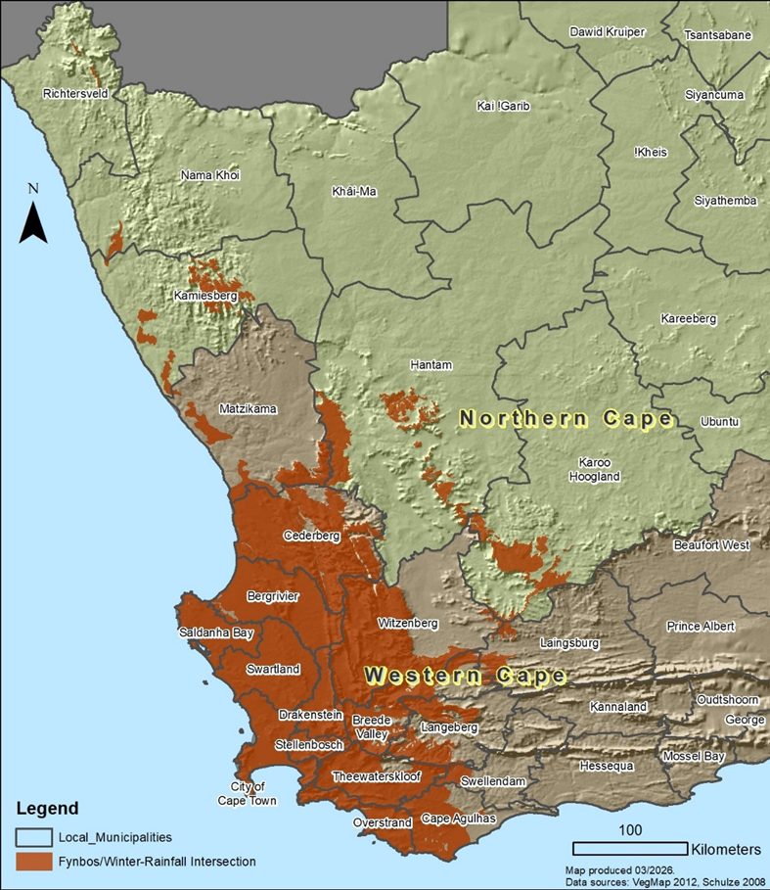

“Rooibos”/”Red Bush” is produced, dried and processed in the following geographical areas of South Africa:

- In the Western Cape Province, the local municipalities of Bergrivier, Breede Valley, Cape Agulhas, Cederberg, City of Cape Town, Drakenstein, Langeberg, Matzikamma, Overstrand, Saldanha Bay, Stellenbosch, Swartland, Swellendam, Theewaterskloof and Witzenberg (Figure 2).

- In the Northern Cape Province, only the local municipality of Hantam (Figure 3).
Figure 2: Map of Western Cape Province Municipalities
(Source: https://municipalities.co.za/)
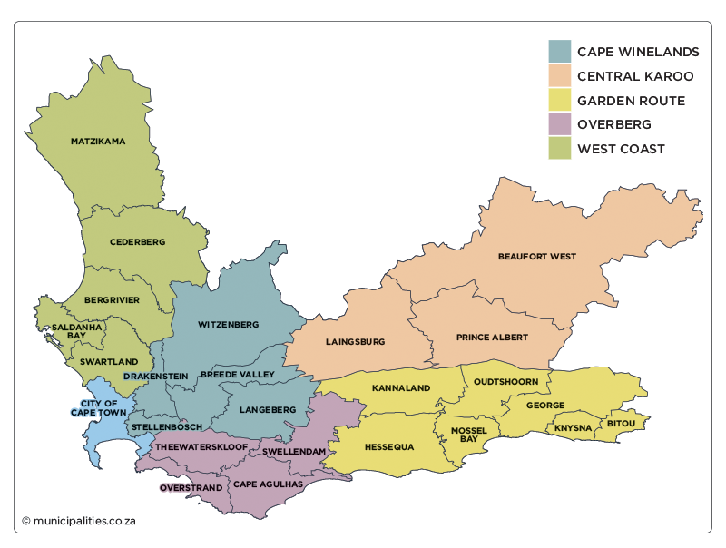

Figure 3: Map of Northern Cape Province Municipalities
(Source: https://municipalities.co.za/)
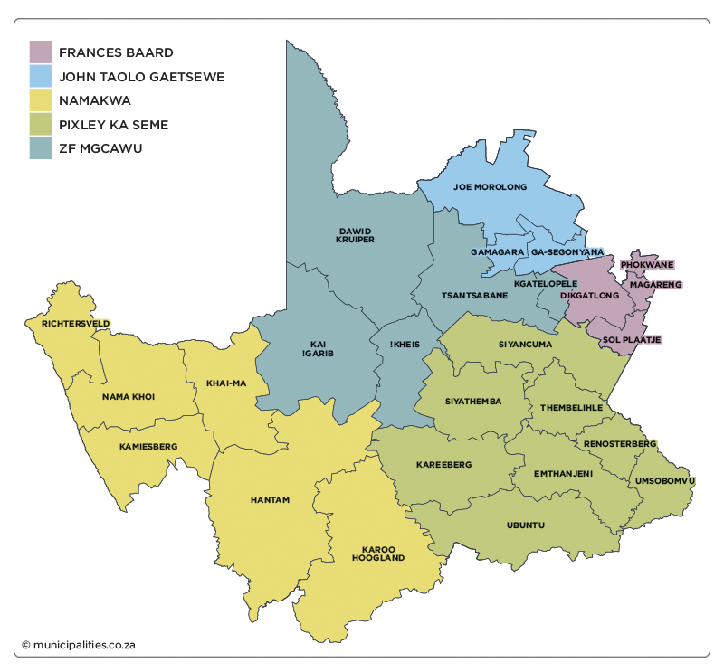

2.3 The link between “Rooibos”/“Red Bush” and the designated geographical area

These unique sensory characteristics of “Rooibos”/“Red Bush” can be ascribed to the complex phenolic chemistry of Aspalathus linearis. The flavonoid composition of “Rooibos”/“Red Bush” is unique in that it contains aspalathin and aspalalinin, as well as the rare compounds nothofagin and enolicphenylpyruvic acid glucoside. Whereas most of the flavonoids occur ubiquitously in the plant kingdom, until now aspalathin has only been detected in Aspalathus linearis, creating it’s unique sensory characteristics.

The taste and specific composition of “Rooibos”/“Red Bush” is directly related to the climate where it is grown. Cold wet winters, growth in spring and early summer and then maturity and polyphenol accumulation as the weather gets hotter and drier. It follows that, if Aspalathus linearis is grown in any other climate, it will not have the same characteristics as “Rooibos”/“Red Bush” due to less polyphenol accumulation. In order to understand this causal relationship, it is important to understand the way in which Aspalathus linearis has adapted to the unique climate, soils and geography of this area.

“Rooibos”/“Red Bush” has developed some unique characteristics (i.e. shape and coating of leaves, etc.) to adapt to this harsh climate. In addition to a network of lateral roots just below the soil surface that can utilize even light precipitation. The plant has a long tap root that reaches as deep as two meters and helps the plant find moisture and reach water during the dry summers. The lateral roots enable the plant to enhance phosphorus acquisition from the soil which is among the most phosphorous impoverished in the world.

One of the biggest secrets underlying the adaptation of “Rooibos”/“Red Bush” in this harsh climate can be found in its symbiotic relationship with the nitrogen-fixating bacteria on its roots. As a legume, the bacteria on the roots of Aspalathus linearis convert nitrogen dioxide to biologically useful ammonia in a process known as nitrogen fixation. The plant absorbs the nitrogen and benefits from it in exchange for providing the bacteria with food. This process is common for legumes, but what is unique in the case of Aspalathus linearis is that the indigenous bradyrhizobia are naturally tolerant of acidity and the plant has some ability to modify its rhizosphere pH in order to promote symbiotic establishment and nutrient availability to plants growing in this otherwise infertile acidic soil. It has been reported in the literature that very few symbioses can tolerate such extremities of soil acidity and low nutrient stress whilst fixing high levels of nitrogen as exhibited by Aspalathus linearis.

- Description of production process

3.1 During the production of “Rooibos”/“Red Bush” the following steps shall take place in the identified geographical area:

- Seeds of the plant Aspalathus linearis is gathered by local seed gathers, often from ant heaps.
- The gatherers then supply the seeds to “Rooibos”/”Red Bush” nurseries who use it to strengthen the commercial gene pool. This is an age-old tradition still being implemented today and an essential part “Rooibos”/”Red Bush” cultivation as it is known today.
- It is commercially cultivated or grows naturally in the wild.
- It is harvested from the cultivated fields (either mechanically or by hand) or from the wild (by hand only).
- It is cut and dried at a tea court (drying yards). The tea court may be on or off-farm, but it must be in the designated area.
- The dried product is sorted and prepared.
- It is pasteurised and packed in containers for local and international trade.

3.2 During the production of “Rooibos”/“Red Bush” the following steps may take place outside the identified geographical area:

- Movement of bulk containers.
- Packing in commercial containers.
- Further processing and inclusion in other products.
- Labelling and traceability

4.1 Labelling of containers

- 100% Pure “Rooibos”/”Red Bush”

Containers containing only “Rooibos”/”Red Bush” shall carry the GI name “Rooibos”/“Red Bush” with the prescribed SA GI Logo in the vicinity of the name.

- “Rooibos”/”Red Bush” mixtures with “Rooibos”/”Red Bush” as main ingredient

(i) Where “Rooibos”/”Red Bush” is mixed with other ingredients the labelling shall be “Rooibos with….” or “Red Bush blended with….” or similar description.
(ii) The final product shall still be recognizable as ‘“Rooibos” / ”Red Bush “as characterised in the description of the product.
(iii) The “Rooibos”/”Red Bush” may indicate that it is a SA GI next to the GI name (without the SA GI Logo).
(iv) The products in the blends shall be indicated in descending order.

- “Rooibos”/”Red Bush” mixtures with “Rooibos”/”Red Bush” not the main ingredient

(i) Where “Rooibos”/”Red Bush” is mixed with other ingredients and the “Rooibos”/”Red Bush” is not the main ingredient, then the “Rooibos”/”Red Bush” shall be used in sufficient quantities to confer an essential characteristic to the product concerned.
(ii) The product shall not contain any other “comparable ingredient”, i.e. any other ingredient which may partially or totally replace “Rooibos”/”Red Bush”’.
(iii) The “Rooibos”/”Red Bush” may indicate that it is a SA GI next to the GI name (without the SA GI Logo).

- “Rooibos”/”Red Bush” mixtures with comparable ingredients

Where “Rooibos”/”Red Bush” is mixed with comparable ingredients (i.e. any other ingredient which may partially or totally replace “Rooibos”/”Red Bush”) and “Rooibos”/ Red Bush” is not the main ingredient imparting the main characteristics to the product, then the fact that “Rooibos”/”Red Bush” is a GI shall only be indicated in the ingredients list.

- Reconstituted “Rooibos”/”Red Bush” extracts and reconstituted “Rooibos”/”Red Bush” infused with liquid flavourants

Reconstituted “Rooibos”/“Red Bush” extracts (e.g Iced “Rooibos”/“Red Bush” Drink) and reconstituted “Rooibos”/“Red Bush” extracts infused with liquid flavourants (e.g. Citrus Flavoured Iced “Rooibos”/“Red Bush” Drink) can be called “Rooibos”/“Red Bush” on the conditions that:
  - “Rooibos”/“Red Bush” is the main ingredient (after water).
  - The exact percentage of “Rooibos”/“Red Bush” content appears on the label/packaging as required by QUID (point (g)).
  - The final product must still be recognizable as “Rooibos”/“Red Bush” as characterized in the description of the product.
  - The product may indicate that the “Rooibos”/”Red Bush” is a SA GI in the manner indicated in point (b) above.

- Use of “Rooibos”/”Red Bush” in other products

When “Rooibos”/“Red Bush” and “Rooibos”/“Red Bush” extracts are used in other products (e.g. dairy, jams and marmalade, edible ices, honey, canned fruit and vegetables, etc.), “Rooibos”/“Red Bush” may be mentioned in or close to the trade name of the product incorporating it as well as in the labelling, presentation and advertising relating to that foodstuff, provided that the following conditions are met:
(i) The product should not contain any other “comparable ingredient”, i.e. any other ingredient which may partially or totally replace “Rooibos” / “Red Bush”.
(ii) “Rooibos”/“Red Bush” should be used in sufficient quantities to confer an essential characteristic to the product concerned.
(iii) The percentage of incorporation of “Rooibos”/“Red Bush” should ideally be indicated in or in close proximity to the trade name of the relevant foodstuff or, failing that, in the list of ingredients, in direct relation to the ingredient in question.
(iv) The product may indicate that the “Rooibos”/”Red Bush” is a SA GI in the manner indicated in point (b) above.
  - Any terms, abbreviations or symbols accompanying the registered name used in labelling, within or close to the trade name or in the list of ingredients of the product shall not convey the impression that the product itself is a Designation of Origin or Geographical Indication.

- Quantitative Ingredient Declarations (QUID)

For “Rooibos”/”Red Bush” mixtures Quantitative Ingredient Declarations (QUID) are required, as specified in the regulations published under the Foodstuffs, Cosmetics and Disinfectants Act, 1972 (Act No. 54 of 1972).

- Bulk containers

(i) “Rooibos”/”Red Bush” exported in bulk containers shall indicate the GI name “Rooibos”/ “Red Bush” and the SA GI Logo in the vicinity of the name, provided that it is packed as a single commodity.
(ii) “Rooibos” / ”Red Bush” exported in bulk containers may be repacked in the destination country and indicate the GI name “Rooibos”/“Red Bush” and the SA GI Logo in the vicinity of the name only if it is packed as a single commodity.

- Other

The labelling of the “Rooibos” / “Red Bush” containers shall also comply with the requirements of the “Regulations regarding control over the sale of Rooibos and Rooibos mixtures in the Republic of South Africa” (No.R.322 of 22 March 2002) and the “Standards and Requirements regarding control of the export of Rooibos and Rooibos mixtures” (Notice 18 of 23 January 2015), and their subsequent revisions.

4.2 Traceability

The producers shall have traceability in place during all production and distribution steps of “Rooibos”/”Red Bush” and this shall include:
- Identity.
- Location.
- Documentation.
- Product movement.

Traceability examples:
- Document each “Rooibos”/“Red Bush” batch and record the farm of origin.
- Documented proof of purchase from an approved farm in the designated area.
- Keep a register of “Rooibos”/“Red Bush” products received.
- Record of movement of the “Rooibos”/”Red Bush” from drying court to processing if that movement is done.
- Record of the processing of all “Rooibos”/“Red Bush”.
- Record of all “Rooibos”/“Red Bush” packaged for bulk distribution and consumer retail.

Further information regarding the registered South African GI Rooibos / Red Bush is available on the Department’s website at www.nda.gov.za

https://www.nda.gov.za/index.php/publication/543-geographical-indications-and-designations-of-origin

B.M. MAKHAFOLA
Executive Officer: Agricultural Product Standards

