
DIRECTORATE GENETIC RESOURCES
Private Bag X973, Pretoria, 0001
Harvest House, 30 Hamilton Street,
Arcadia, Pretoria, 0002
Tel: 012 319 6382, Fax: 012 319 6298,
E-mail: NompumeleloM@dalrrd.gov.za

APPLICATION FOR COMMODITY CLEARANCE OF GENETICALLY MODIFIED ORGANISMS (GMOs) IN SOUTH AFRICA

Notes:
- Host or unmodified organism refers to an organism prior to the genetic modification(s) that results in the organism being classified as a GMO.
- Although this application form is to be used for all commodity clearance applications, it is primarily intended for applications dealing with genetically modified (GM) plants.
- Applicants should substantiate “yes” or “no” answers and provide answers that are detailed enough to enable thorough risk assessment by regulatory bodies. Answers may, where appropriate, be summaries that are based on relevant, peer-reviewed literature.
- Applications with superficial answers may cause significant delays in the review and decision-making process.
- All the data required to assess the application should be included in the application dossier. Applicants should not refer to in-house generated results or data that are not part of the application dossier. Applicants should include substantiating data and reports with the application dossier.
- The application is structured in two tiers:
  - Tier 1. Part I to III of Tier 1 must be completed for all GMOs.
  - Tier 2. Sections in Part IV only need to be completed if the applicant is referred to these sections based on the applicant’s responses in Tier 1. In Part V, only the section relevant to the GMO should be completed.
- Part VI must be completed for all GMOs.
- Figure 1 on page 2 shows a graphical overview of the key parts of the application template, with colour coding used to assist applicants in understanding which parts of the application template they need to complete.
- Complete the affidavit. The affidavit is an inseparable part of the application form.

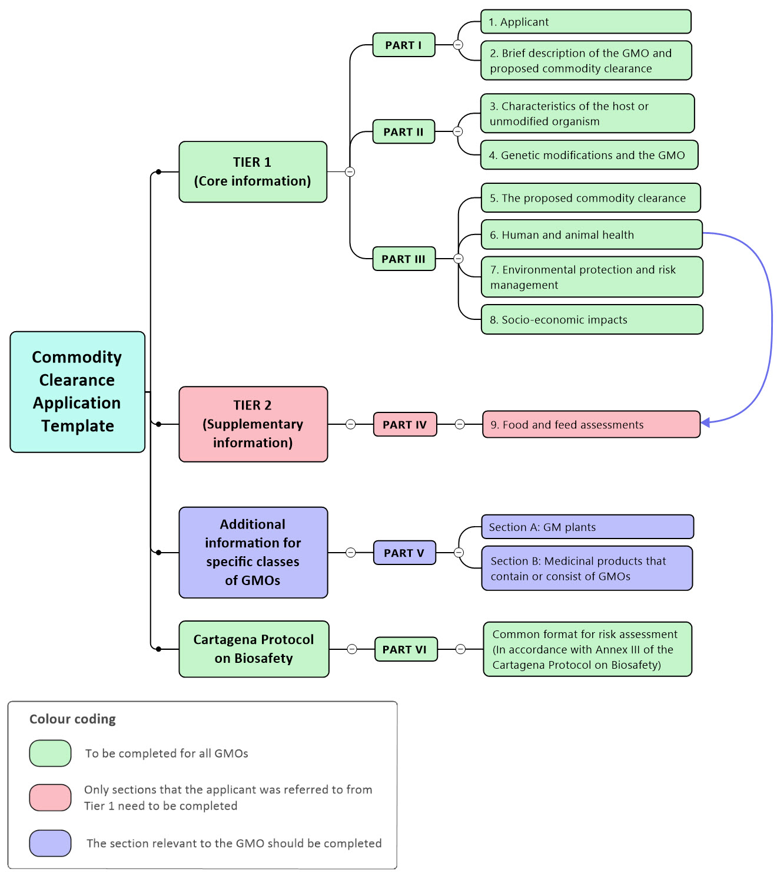
Figure 1. Graphical overview of the two-tier commodity clearance application template. The colour coding shows which parts need to be completed by the applicant: (1) Tier 1 and the Cartagena Protocol on Biosafety sections need to be completed for all GMOs, (2) for Tier 2, sections in Part IV only need to be completed if the applicant is referred to these sections based on the applicant’s responses in Tier 1, and (3) in the “Additional information for specific classes of GMOs” part of the template, only the section relevant to the GMO should be completed. The arrow shows where in the application template an applicant may be referred from Tier 1 (core information) to Tier 2 (supplementary information).
TIER 1 (Core Information)

PART I (to be completed for all GMOs)

- APPLICANT

  - Name of applicant
  - Address of applicant

- BRIEF DESCRIPTION OF THE GMO AND PROPOSED COMMODITY CLEARANCE

  - Provide a unique identifier and brief description of the GMO, the intended function(s) of the genetic modification(s), and the genetically modified trait(s) of the GMO.
  - Provide a brief description of the proposed commodity clearance.
  - Is the unmodified organism indigenous to South Africa or does it have a history of safe use in South Africa?
  - Will or could the commodity imports include a form of the GMO that may enable to GMO to reproduce and/or disseminate in the environment?

PART II (to be completed for all GMOs)

- CharacteristicS of the host OR unmodified organism
  - Specific and common names of the unmodified organism (recipient or parental organism).

  - Describe the natural habitat, geographic distribution, geographic origin, and centres for diversity of the unmodified organism. Also, provide details on the type of environment and the geographical areas for which the unmodified organism is suited.

  - Comment on whether or not the unmodified organism has any adverse effect on:
    - Humans
    - Animals
    - Plants
    - Agricultural production
    - Any other aspect of the environment

  - Reproduction of the unmodified organism:
    - Provide detailed information on the mode(s) of reproduction.
    - Provide detailed information on specific factors affecting reproduction.
    - For pollen spread, identify pollinating agents and the distances to which pollen is known to spread.
    - Provide detailed information on the generation time.

  - Sexually compatible species:
    - Provide information on cultivated species, their distribution, and proximity to the commodity clearance areas (including along transport routes).
    - Give details of wild species and their distribution and proximity to commodity clearance areas.
    - Identify any plants in the area of the commodity clearance that may become cross-pollinated with the host plant.

  - Survivability in the environment of the unmodified organism:
    - Provide details on structures produced by the unmodified organism for survival or dormancy.
    - Provide information on specific factors affecting survivability of the unmodified organism in the environment.

  - Dissemination of the unmodified organism in the environment:
    - Provide details on how the unmodified organism may disseminate in the environment.
    - Provide information on specific factors affecting dissemination of the unmodified organism in the environment.

  - Provide information on how the unmodified organism is usually utilised in agriculture, forestry, medicine, or other areas.

- GENETIC MODIFICATIONS AND THE GMO

  - Was a donor organism(s) used as a source of the nucleic acid sequences used in the genetic modification(s)? If yes, provide:
    - Scientific and common names of the donor organism(s).
    - Provide details of the natural habitat, geographic distribution, geographic origin, and centres for diversity of the donor organism(s).
  - Provide a detailed description of the methods used for the genetic modification(s) and, in cases where vectors were used, describe the nature and source of the vectors used.

  - Provide detailed information on the genetic construct that enacts the genetic modification in the unmodified organism, including the source of donor DNA and the size and intended function of each constituent fragment that is inserted in the host’s genome or that plays a role in making the genetic modification(s). Use maps and tables as appropriate.

  - Provide detailed information on the genetic modification(s) (e.g., base edits, inserted or deleted sequences) and phenotypic trait(s) and characteristics associated with the genetic modifications.
All information provided must be substantiated with appropriate empirical evidence and a description of the methodology used to generate the evidence.
There is no prescribed way for presenting the information, but information should be presented in a way that facilitates thorough review and must include the following:
(a) Identification and location of all inserted sequences (including short indels) and genes, including the copy numbers for all inserts, both complete and partial. The organisation of the inserted genetic material at the insertion site.
(b) Identification and location of all deleted sequence(s), the size of the deleted region(s), and the gene(s) and function(s) that are impacted upon by the deletion(s).
(c) The identification and location of all nucleotide base edits that are part of the planned genetic modification(s).
(d) The molecular methods used for determination of the location(s) of the genetic modification(s) and copy number determinations. The location(s) of genetic modification(s) information should indicate if the modification(s) is in the nucleus, chloroplasts, mitochondria, or maintained in a non-integrated form.
(e) The genetic stability of the modification(s) and the methods used to assess the stability.
(f) The biological activity, trait and phenotypic outcome associated with each genetic modification in the GMO.
(g) The biological activities, traits and phenotypic outcomes that results from the combination of genetic modifications in the GMO.
(h) The phenotypic stability of the GMO.

  - Expression of inserted sequences or genes:
    - Provide information on the expression of inserted sequences or genes.
    - State whether expression is constitutive or inducible. In the case of inducible expression, discuss the induction conditions.
    - Provide information on the rate and level of expression of the products of the inserted sequences or inserted genes and the sensitivity of the measurement of the rate and level.
    - In the case of GM plants, provide information on the expression of the products of the inserted sequences or inserted genes in different plant tissues. For stacked events, provide data on the expression of the inserted sequences relative to that in the parental GM events.
  - Changes in the expression of endogenous genes:
    - Provide information on the expression of previously inactive genes or changes in the expression of endogenous genes intentionally brought about by genetic modification(s) in the GMO.
    - Provide information on the rate and level of expression of previously inactive genes or genes that the levels of expression were intentionally changed by genetic modification(s) in the GMO. State the sensitivity of the measurement of the rate and level.

  - Provide information on how the GMO differs, or is expected to differ, from the unmodified organism with regard to:
    - General traits (including agronomic traits were relevant).
    - Natural habitat and geographic distribution.
    - Reproduction.
    - Dissemination/dispersion, including persistence and invasiveness.
    - Survivability, especially in the spectrum of conditions which are likely to be found in the commodity clearance and surrounding areas.
    - The ability to transfer genetic material to other organisms, including bacteria and plants.
    - Adverse effects on:
      - Humans
      - Animals
      - Plants
      - Agricultural production
      - Any other aspect of the environment
      - Other.
  - Unintended effects:
    - Provide information on the assessment of unintended effects in the GMO (e.g., off-target effects, unintended DNA insertions, and chromosomal rearrangements). Include details of the assessment methods.
    - If unintended effects were observed, provide comprehensive information on the unintended effects and the impact of the unintended effects on the traits and characteristics of the GMO, especially in the context of section 4.7.
  - Provide detailed, implementable protocols or standard operating procedures (SOPs) for:
    - The detection in the environment/other organisms of the genetically modified nucleic acid sequences that define the organism as a GMO.
    - Identification and detection of the GMO in the environment and for distinguishing between the GMO and the unmodified organism.
The responses for 4.9.1 and 4.9.2 should include information on the sensitivity, reliability and specificity of the techniques.
The detailed protocols should be included as annexures to the application.

PART III (to be completed for all GMOs)
- THE PROPOSED COMMODITY CLEARANCE
  - Please indicate why commodity clearance is being requested.
  - Give a description of the intended use of the GMO and/or derived products. Indicate if the derived products are for food/feed or industrial use.
  - Description of any product(s) derived from the GMO:
    - In which sector and under what trade name will the product(s) be marketed?
    - Identify the part of the GMO to be used for the product, the type of product, and the use of the product.
  - Detail specific instructions for the storage and handling of the GMO or GMO parts.
  - When and where will commodity import take place?
  - Who will undertake the commodity import?
  - From which country will the commodity be imported from?
  - Estimate the amount (weight) of the GMO or GMO product(s) that will be imported into South Africa per annum.
  - Brief summary of prior approvals of the GMO:
(Include information on the country, year, location and the authority from which approval was obtained).
    - Submit a list of previously approved general release applications or deregulations in other countries for the GMO.
    - Provide a list of previously approved food and feed applications in other countries for the GMO.

- HUMAN AND ANIMAL HEALTH
  - Provide information on the anticipated extent of exposure to the GMO or its products to humans and animals.
  - Toxicology:
    - Provide details of experiments undertaken to determine the toxicity to humans and animals of the newly expressed proteins (including antibiotic markers) or new constituents other than proteins.
  - Allergenicity:
    - What are the common/major allergens present in the unmodified organism?
    - Provide details of experiments undertaken to determine the allergenicity of the newly expressed gene products (including antibiotic markers) to humans and animals.
    - What evidence is there that the genetic modification described in this application did not result in over-expression of the possible allergens indicated in 6.3.1, i.e., is the expression of the possible allergens in the non-GM counterpart substantially equivalent to that in the GM organism?
    - Provide details of any experiments undertaken to determine the allergenicity of whole GM food or GM feed.
  - If the newly expressed gene products are toxic or allergenic in any way, detail how the commodity clearance will be managed to prevent contact with animals or humans that will lead to discomfort or toxicity.
  - Can the GMO or its products be used for food or feed, or will the GMO or its products enter human food or animal feed chains? If yes, please complete section 9 of Part IV.
  - What are the implications of the proposed activity (commodity clearance) with regard to the health and safety of the workers, cleaning personnel and any other person that will be directly or indirectly involved in the activity? Please take into consideration the provisions of the Occupational Health and Safety Act, 1993 (Act No. 85 of 1993 as amended by Act No. 181 of 1993) (and accompanying regulations) and indicate the proposed health and safety measures that would be applied.

- ENVIRONMENTAL PROTECTION AND RISK MANAGEMENT

  - Provide a detailed risk management plan that will be implemented for the commodity clearance. The plan should include specific information for the storage and handling of the GMO that will avoid misuse or accidental release of the GMO into an environment for which it was not intended. This information should include, but is not limited to:
- Containment and confinement of GMOs
- Movement of GMOs
- Storage and inventory of GMOs
- Disposal of residual or excess GMOs
- Where only a portion of the GMO is to be used for the product, explain disposal of unused parts of the GMO
- Harvest and/or disposal of GMOs after completion of the activity
- In the case of GM plants, identification of registered agrochemicals that can be used to eliminate the GM plant from the environment.
- Cleaning of any equipment used during the activity
- Monitoring for compliance to permit conditions
- Restriction of unlawful access to GMOs
- Management and maintenance of records and reporting
- The contingency plans and emergency procedures that will be applied in the event of accidental release of the GMO into the environment for which it was not intended. In the case of vegetative reproduction of a GM plant, describe methods to be used to limit vegetative spread of the GM plant into the environment.
The risk management plan needs to be based on the GMO’s characteristics, such as the methods of reproduction, dissemination and the survivability of reproductive structures in the receiving environment.

  - Submit an evaluation of the foreseeable or likely impacts that the GMO will have in the event of accidental release of the GMO into the environment. The impact assessment should consider abiotic and biotic components of the environment, such as the impacts on non-target organisms, biodiversity and ecosystems.

  - Please indicate any risk management measures that end-users of this commodity will have to adhere to with regard to handling and use.

- SOCIO-ECONOMIC IMPACTS

  - Specify what, if any, positive or negative socio-economic impacts the commodity clearance of the GMO or GMO products will have on South Africa and its people. The information may include but is not limited to information on the impact on the following:
- Income, competitiveness or economic markets
- Food security.

TIER 2 (Supplementary Information)

PART IV (only sections that the applicant was referred to from Tier 1 need to be completed)

- FOOD AND FEED ASSESSMENTS
(To be completed if you answered yes to the question in section 6.5)
  - Provide information on the anticipated intake of the GMO or its products for humans and animals.
  - Compositional analysis and feeding studies:
Compositional analyses and feeding studies should be done using widely-accepted industry standards or guidelines (e.g., OECD or WHO guidelines) and appropriate statistical methods.
The Appendix contains guidance for the completion of section 9.2 for commodity clearance applications of GM plants.
    - Compositional analysis:
Provide the results of compositional analyses, and highlight any changes in natural food and feed constituents, including toxicants, metabolites and anti-nutritional factors.
Discuss the significance or biological relevance of any statistically significant differences between the GMO and appropriate comparators.
    - Feeding studies:
      - Provide the results of nutritional performance or comparison studies.
      - Provide the results of toxicological studies undertaken with the GMO or GM plant (e.g., whole GM food and/or GM feed).
For both (a) and (b), discuss the significance or biological relevance of statistically significant differences between the GMO and appropriate comparators.

Additional information for specific classes of GMOs

PART V (the section relevant to the GMO should be completed)

SECTION A: GM plants
Note to applicants: no information is currently required for this section.

SECTION B: Medicinal products that contain or consist of GMOs
Note to applicants: no information is currently required for this section.

Cartagena Protocol on Biosafety

PART VI

COMMON FORMAT FOR RISK ASSESSMENT
(In accordance with Annex III of the Cartagena Protocol on Biosafety)

Risk assessment details
- Country Taking Decision: | South Africa
- Title: | <Text entry>
- Contact details: | <Standard contact address details: name, function (job title/designation), organization, address, phone, fax, email, website>
LMO information
- Name and identity of the living modified organism: | <Text entry – Identity of the living modified organism, and the differences between the biological characteristic of living modified organism and those of the recipient organism or parental organisms>
- Unique identification of the living modified organism: | <Text entry>
- Transformation event: | <Text entry>
- Introduced or Modified Traits: | Choose the trait from the following list:  A. Abiotic environmental tolerance  - Altered photoperiod sensitivity  - Cold or heat tolerance  - Drought or water tolerance  - Other abiotic environmental tolerance  B. Altered growth, development and product quality  - Altered ripening or flowering  - Colouration  - Fertility restoration  - Growth rate or yield  - Male sterility  - Nutritional composition (incl. allergenicity)  - Other growth, development and product quality  - Selectable marker genes and reporter genes  - Uptake or degradation of environmental pollutants  Chemical tolerance  - Herbicide tolerance  - Other chemical tolerance  Medical products  - Animal vaccines  - Development of transplant organs  - Other medical products  - Production of pharmaceuticals  Pest resistance  - Bacterial resistance  - Fungus resistance  - Insect resistance  - Nematode resistance  - Other pest resistance  - Virus resistance  and  <text entry for other, not on the list>
- Techniques used for modification: | <Controlled vocabulary for common techniques - Please select techniques used for the transformation: plasmid carried by Agrobacterium tumefaciens, biolistic methods, breeding, electric shock (poration), osmotic shock> and  <text entry – for other, not on the list>
- Description of gene modification: | <Text entry>
Characteristics of modification
- Vector characteristics (Annex III.9(c)): | <Text entry - Characteristics of the vector, should include its identity, if any, and its source or origin, and its host range >
- Insert or inserts (Annex III.9(d)): | <Text entry - Genetic characteristics of the inserted nucleic acid and the function it specifies, and/or characteristics of the modification introduced>
Recipient organism or parental organisms (Annex III.9(a)):
- Taxonomic name/status of recipient organism or parental organisms: | <Controlled vocabulary: agreed international standards>  and <text entry – for other, not on the list>
- Common name of recipient organism or parental organisms: | <Controlled vocabulary with thesaurus> and <text entry – for other, not on the list>
- Point of collection or acquisition of recipient or parental organisms: | <Text entry >
- Characteristics of recipient organism or parental organisms related to biosafety: | <Text entry >
- Centre(s) of origin of recipient organism or parental organisms: | <Text entry - Describe the exact location and give geographical coordinates>
- Centres of genetic diversity, if known, of recipient organism or parental organisms: | <Text entry - Describe the exact location and give geographical coordinates>
- Habitats where the recipient organism or parental organisms may persist or proliferate: | <Text entry - Description of the habitat where the organisms may persist or proliferate>
Donor organism or organisms (Annex III.9(b)):
- Taxonomic name/status of donor organism(s) | <Controlled vocabulary: agreed international standards> and <text entry for other, not on the list>
- Common name of donor organism(s): | <Controlled vocabulary with thesaurus> and <text entry for other, not on the list>
- Point of collection or acquisition of donor organism(s): | <Text entry - the exact location and geographical coordinates>
- Characteristics of donor organism(s) related to biosafety: | <Text entry - Relevant biological characteristics of donor organisms>
Intended use and receiving environment
- Intended use of the LMO (Annex III 9(g)): | <Text entry - Information relating to the intended use of the living modified organism, including new or changed use compared to the recipient organism or parental organisms>
- Receiving environment (Annex III.9(h)): | <Text entry - Information on the location, geographical, climatic and ecological characteristics, including relevant information on biological diversity and centres of origin of the likely potential receiving environment>
Risk assessment summary
- Detection/Identification method of the LMO (Annex III.9(f)): | <Text entry - Suggested detection and identification methods and their specificity, sensitivity and reliability>
- Evaluation of the likelihood of adverse effects (Annex III.8(b)): | <Text entry - An evaluation of the likelihood of these adverse effects being realized, taking into account the level and kind of exposure of the likely potential receiving environment to the living modified organism>
- Evaluation of the consequences (Annex III.8(c)): | <Text entry - An evaluation of the consequences should these adverse effects be realized>
- Overall risk (Annex III.8(d)): | <Text entry - An estimation of the overall risk posed by the living modified organism based on the evaluation of the likelihood and consequences of the identified adverse effects being realized>
- Recommendation (Annex III.8(e)): | <Text entry - A recommendation as to whether or not the risks are acceptable or manageable, including, where necessary, identification of strategies to manage these risks>
- Actions to address uncertainty regarding the level of risk (Annex III.8(f)): | <Text entry - details about any further information that has been requested where there is uncertainty regarding the level of risk, as well as any information on risk management strategies and/or monitoring of the LMO in the receiving environment>

Additional information
- Availability of detailed risk assessment information: | <Text entry - Please indicate whether more details on the risk assessment are available and how they can be accessed>
- Any other relevant information: | < Text entry - any other information that is relevant to the risk assessment. e.g. information of non CBI nature that was included in the original application but is not included in this form>
- Attach document: | Not applicable to applicant<Specific types of entry: option to choose a file from the local source and 'upload' a copy to the BCH server>
- Notes: | <Text entry>

AFFIDAVIT/STATEMENT
(to be completed in the presence of a Commissioner of Oaths)

I………………………………………………………………………………………………….
ID Number…………………………………………. Age ………………..
Working address ……………………………………………………………………..
Tel ………………………..(w) ……………………………(h) ……………………………(cell)

Declare under oath in English / confirm in English –

……………………………………………………………………………………………………………………………………………………………………………………………………………………………………………………………………………………………………………………………………………………………………………………………

I am familiar with, and understand the contents of this declaration. I have no objection/have objection to taking the prescribed oath. I consider the prescribed oath as binding to my conscience.

Place: ………………………………….. Date: ………………………..

Time: ……………………………………

Signature: ………………………………………

I certify that the above statement was taken from me and that the deponent has acknowledged that he/she knows and understands the contents of the statement. The statement was sworn to/affirmed before me and deponents signature/mark/thumb print was placed thereon in my presence.

At: ………………………………… on ……………………………… at ……………………….

…………………………………………………..
Commissioner of Oaths
(details to be provided on physical and postal address e.g., stamp of police station)

………………………………………………….
Force number/Rank/Name – print

Directions for the applicant:

(This page must be excluded from the documents submitted to the Registrar’s office)

- Please complete all relevant sections of the questionnaire CLEARLY.
- Please provide 1 original and 15 copies (9 additional copies if application for a crop with no previous general release approval) of the application with confidential information for use by the regulatory bodies appointed in terms of the Genetically Modified Organisms Act, 1997 (Act No. 15 of 1997).
Please confirm with the Office of the Registrar with regard to submission of electronic applications
- Please provide an additional hard copy and electronic version of the application containing no confidential information. Non-Confidential Business Information (Non-CBI) copy - this is your application where you have deleted any information that you regard as confidential business information. Please take note that you must make reference to the specific section of the Promotion of Access to Information Act, 2000 whenever you “delete” information in this application. This copy must be clearly marked NON-CONFIDENTIAL, and will be made available to the public. This copy of the application must be submitted to the Registrar one day after the placing of the public notices.
- Please provide an electronic and hard copy of a risk assessment conducted in accordance with Annex III of the Cartagena Protocol on Biosafety and in the format prescribed below.
- Please conduct a public notification in accordance with Regulation 9 of the GMO Act, and making use of the guideline document available on the website of the department. Copies of the public notification must be submitted with the application.
- Please submit all relevant documentation to the Registrar at the address indicated in the application form.
- The appropriate fee stipulated under the GMO Act must accompany the application. Please note that the Registrar’s office does not accept cash.

APPENDIX

Guidance for section 9.2 (compositional analysis and feeding studies)

- Compositional data should be provided for the GM crop (including stacked events) under consideration in the application.
- For both compositional analyses and feeding studies, provide clear information on:
- the choice of non-GM comparators,
- the production of material for the comparative assessments, including locations, replicates and growing seasons, and
- the baselines used for consideration of natural variations.
- For all stacked event applications that include a complete, stand-alone risk assessment package for the stacked event, there is no expectation that data will be provided for the parental GM events.
- For stacked events that contain RSA-approved parental GM events and a parental GM event that has not yet been approved in the RSA, the safety assessment of the stacked event may take into consideration the demonstrated safety of the parental GM events (i.e., a data bridging approach may be used); however, detailed safety assessments, including feeding and toxicological studies, would be expected for the unapproved GM event in the stack. Alternatively, a full risk assessment package may be submitted for the stacked event under consideration. For either approach, agronomic/phenotypic, expression and compositional data for the stacked event are expected. The expression levels of the inserted sequences relative to those in the parental GM events need to be taken into consideration (see also 7.5.3).
- For all stacked event applications that do not include a complete risk assessment package for the stacked event (e.g., prior RSA approval for parental GM events is used to argue that feeding studies are not required; see point 4 above), the full safety assessment package for each parental GM event needs to be included in the application dossier.
- For stacked events in general: in the event that the compositional analyses show that there are statistically significant differences of biological relevance between the stacked event and the non-GM comparators, further safety assessments, including feeding and toxicological studies, of the stacked event under consideration would be expected.

- Lower-level stack applications: in the event that compositional analyses show that there are not statistically significant differences of biological relevance between a lower-level stack (e.g., AxBxC) and both a previously RSA-approved higher-level stack (e.g., AxBxCxD) and non-GM comparators, then the need for further safety assessments should be considered on a case-by-case basis. However, in all such applications, the full risk assessment package (including expression and feeding studies) for each parental GM event needs to be included in the application dossier. In these types of applications, the expression levels of the inserted sequences relative to those in the parental GM events need to be taken into consideration (see also 7.5.3).
- For all newly assessed single events: besides compositional data, further detailed safety assessments, including feeding and toxicological studies, for the GM crop under consideration are expected.

