CROP ESTIMATES COMMITTEE

DATE: 27 August 2008
TIME: 10:00
VENUE: Board Room, 7th Floor, Sefala Building, 503 Belvedere Street, Arcadia, Pretoria.

AGENDA

FINAL PRODUCTION ESTIMATE OF SUMMER CROPS (2007/08) AND REVISED AREA ESTIMATE AND FIRST PRODUCTION FORECAST OF WINTER CROPS (2008)

1. OPENING AND WELCOME
2. ATTENDANCE
3. PERSONALIA
4. FINALISATION OF AGENDA
5. APPROVAL OF PREVIOUS MINUTES
5.1 Meeting held on 24 July 2008
6. MATTERS ARISING
6.1
6.2
7. ADDITIONAL ITEMS
7.1 Objective yield determination: 2008/09 production season WH Kilian
7.2
8. WEATHER CONDITIONS: INFORMATION SESSION
- INPUTS FROM OTHER DATA SUPPLIERS
9.1 National Crop Statistics Consortium
10. WINTER CROPS (2008 SEASON)
10.1 Revised area estimate and first production forecast
11. SUMMER CROPS (2007/08 Season)
11.1 Final production estimate
12. NEXT MEETING – 23 September 2008
-------------000-------------

MINUTES OF THE CROP ESTIMATES COMMITTEE MEETING HELD ON 24 July 2008 AT 10:00, BOARD ROOM, 7TH FLOOR, SEFALA BUILDING, ARCADIA, PRETORIA.
1. OPENING AND WELCOME
The Chairperson, Mr R.D. Dredge, welcomed the attendees.
2. ATTENDANCE
PRESENT:
Mr R. Dredge Chief Director, Economic and Statistical Services, DoA
Mr B. Netshifhefhe Agricultural Statistics, DoA
Mrs R. Beukes Agricultural Statistics, DoA
Ms M. Scheepers Agricultural Statistics, DoA
Ms O. Mathole Agricultural Statistics, DoA
Mrs W. Durand ARC-Grain Crops Institute
Mr T. Newby ARC-Institute for Soil, Climate and Water
Mr J. Malherbe ARC-Institute for Soil, Climate and Water (partial attendance)
Mr W. Kilian ARC-Small Grains Institute
Mrs L. Mellet NAMC
Mr H. Cerfonteyn PDA-Western Cape
Mr A. Fourie PDA-Free State
Dr T.T. Silwana PDA-Eastern Cape
Mr G. Müller PDA-KwaZulu-Natal
Mr J. Slabbert PDA-Limpopo
Mrs Z. Rakuambo PDA-Gauteng
Mrs E. Victor PDA-North West
ABSENT WITH APOLOGY:
Ms E. Matsei Director, Agricultural Statistics, DoA
Ms A. Swanepoel PDA-Northern Cape
Mr M.L. Scheltens PDA-Mpumalanga
- PERSONALIA
The following members were congratulated on their birthdays during July:
Ellen Matsei, Rona Beukes, Lizette Mellet, Annette Swanepoel, Jaco Slabbert and Fanie Ferreira.
4. APPROVAL OF PREVIOUS MINUTES
The minutes of the meeting held on 26 June 2008, were accepted without any amendments.
5. MATTERS ARISING
5.1 Eastern Cape: PICES results reviewed
Ms Scheepers reported that the matter has not been resolved yet. It was suggested that the item be removed from the agenda until further notice.
6. ADDITIONAL ITEMS
6.1 Letter from Grain Silo Industry (GSI)
Mrs Beukes reported that a letter was received from GSI on the 17th June 2008 where they indicated that their Directors decided that the CEC has to collect the monthly estimates themselves as from July 2008. The letter from GSI is attached as Annexure A. During the collection of the information, some problems were experienced that need to be addressed in the coming months.

6.2 Correspondence from Maize Forum
Mrs Beukes reported that in attempt to arrange another meeting date between the CEC and the Maize Trust, the Maize Forum Steering Committee indicated that the issue would rather be taken up directly with the DG of the DoA.
7. WEATHER CONDITIONS: INFORMATION SESSION
Mr J. Malherbe of the ARC: ISCW presented an overview of the weather conditions.
Total rainfall for July 2008 compared to the long term mean:

Considering the rainfall map for the period 1 to 20 July 2008, the rainfall pattern was such that most of the interior areas received between 0 to 25% of their average rainfall for July, while most of the winter rainfall areas received above-normal (100 to 200% of the average) rainfall. Exceptions are isolated areas of the North West and Limpopo Provinces. The western parts of the Western Cape were characterised by flood occurrences during July, especially the Swartland areas, but with reference to the Rûens areas - limited rainfall was received.

Expected total rainfall forecast for the period August to October 2008:
According to the Seasonal Consensus Probabilistic Forecast of expected rainfall, it was reported that the country is in a more neutral phase and although temperatures are rising, it won’t reach the El Niño threshold. It was reported that an incidence of a wetter winter season and an early start to the summer rainfall season could occur over the country.
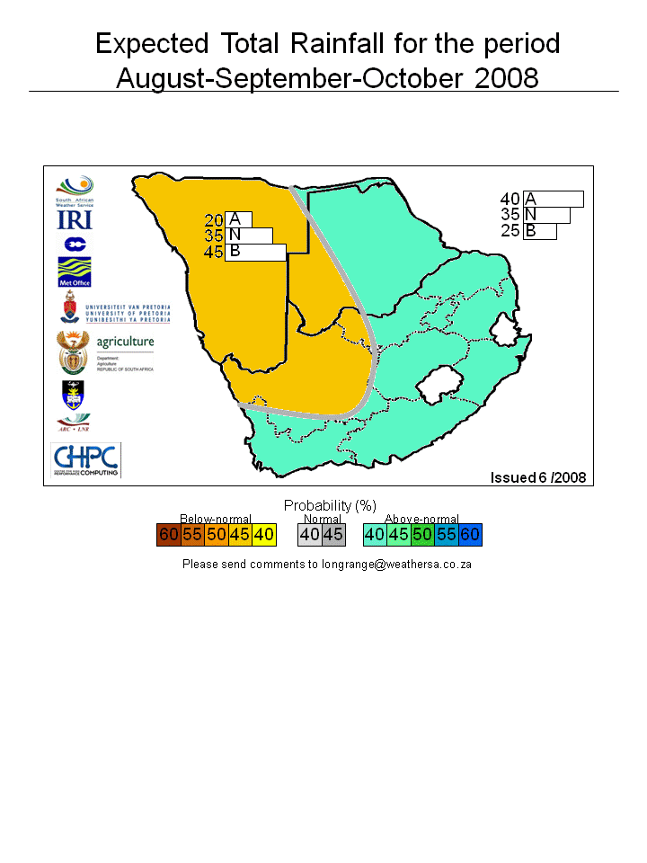

8. INPUTS FROM OTHER DATA SUPPLIERS
Inputs regarding projected crop sizes and yield potential were received from the PDAs, ARC:GCI, SACOTA and DPO.
9. WINTER CROPS (2008 PRODUCTION SEASON)
9.1 Preliminary area estimate

CROP | AREA PLANTED  2008  HA  A | AREA PLANTED  2007  HA  B | FINAL CROP  2007  TONS  C | CHANGE  2008 vs 2007  %  A/B
Commercial:
Wheat | 752 500 | 632 000 | 1 905 000 | +19,07
Malting barley | 70 000 | 73 360 | 222 500 | -4,58
Canola | 35 000 | 33 200 | 38 150 | +5,42
TOTAL | 857 500 | 738 560 | 2 165 650 | +16,10

9.2 Discussion

WHEAT: | The preliminary area estimate for wheat is 752 500 ha, which is 19,1% more than the 632 000 ha planted for the previous season. An estimated 350 000 ha or 47% are in the Western Cape, 290 000 ha or 39% in the Free State and 46 000 ha or 6% in the Northern Cape.
OTHER CROPS: | The preliminary area estimate for malting barley is 70 000 ha, which is 4,6% less than the 73 360 ha of last season. The area planted to canola is 35 000 ha, or 5,4% more than the 33 200 ha planted for the previous season.

10. SUMMER CROPS (2007/08 PRODUCTION SEASON)
10.1 Sixth production forecast

Crop | Area Planted  2007/08  Ha | 6th Forecast  2007/08  Tons | 5th Forecast  2007/08  Tons | Area Planted  2006/07  Ha | Final Crop  2006/07  Tons | Change  2007/08 vs 2006/07  %
 | (A) | (B) | (C) | (D) | (E) | (B) ÷ (C)
Commercial:
White Maize | 1 737 000 | 6 861 400 | 6 861 400 | 1 624 800 | 4 315 000 | +2,60
Yellow Maize | 1 062 000 | 4 736 200 | 4 736 200 | 927 000 | 2 810 000 | +3,59
Total maize | 2 799 000 | 11 597 600 | 11 597 600 | 2 551 800 | 7 125 000 | +3,00
Sunflower seed | 564 300 | 885 560 | 872 060 | 316 350 | 300 000 | +6,60
Soya-beans | 174 400 | 322 995 | 328 195 | 183 000 | 205 000 | +5,71
Groundnuts | 54 200 | 85 360 | 85 360 | 40 770 | 58 000 | +3,86
Sorghum | 89 800 | 269 425 | 272 475 | 69 000 | 176 000 | +5,65
Dry beans | 43 800 | 58 975 | 58 975 | 50 725 | 39 545 | -
TOTAL | 3 725 500 | 13 219 915 | 13 214 665 | 3 211 645 | 7 903 545 | +3,34

10.2 Discussion

COMMERCIAL MAIZE: | The size of the expected commercial maize crop remained unchanged at 11,598 mill. tons. The area planted also remained unchanged at 2,799 mill ha with an expected yield of 4,14 t/ha.  The area for white maize is 1,737 mill. ha, and for yellow maize it is 1,062 mill. ha. The ratio of white to yellow maize plantings is 62:38 as against the previous seasons’ 64:36.  The production forecast of white maize is 6,861 mill. tons with an expected yield of 3,95 t/ha. In the case of yellow maize the production forecast is 4,736 mill. tons with a yield of 4,46 t/ha.
SUNFLOWER SEED: | The production forecast for sunflower seed is 885 560 tons, which is 1,6% more than the 872 060 tons of the previous forecast. The estimated area planted to sunflower seed remained unchanged at 564 300 ha, while the expected yield is 1,57 t/ha.
OTHER CROPS: | The production forecast for soya-beans decreased by 1,6% to 322 995 tons. The area planted to soya-beans remained unchanged at 174 400 ha, while the expected yield is 1,85 t/ha.  The expected groundnut crop remained unchanged at 85 360 tons. The area estimate also remained unchanged at 54 200 ha, while the expected yield is 1,57 t/ha.  The production forecast for sorghum decreased by 1,1% to 269 425 tons. The area estimate for sorghum was left unchanged at 89 800 ha, while the expected yield is 3,0 t/ha.  In the case of dry beans, the production forecast as well as the area planted remained unchanged at 58 975 tons and 43 800 ha, respectively. The expected yield is 1,35 t/ha.
SUBSISTENCE AGRICULTURE: | The production forecast as well as the area planted to maize in the subsistence agricultural sector was left unchanged at 497 980 ha and 464 069 tons, respectively.

11. PRESENTATION - “Phenological stages of the maize plant”
The official meeting proceedings ended at 11:30. As no member is allowed to leave the meeting venue before 12:00, Mrs Durand willingly made a presentation on the “Phenological stages of the maize plant” to make up time until 12:00.
12. The meeting adjourned at 12:00.
13. NEXT MEETING
The next meeting of the Crop Estimates Committee will be held DV on Wednesday, 27 August 2008 at 10:00. The meeting will be held in the Board Room, 7th Floor, Sefala Building, 503 Belvedere Street, Arcadia, Pretoria.

