 | crop estimates committee | 
 | oesskattingskomitee
From/Van: Rodney D. Dredge
Tel: 012 319 6507  Fax/Faks: 012 319 6211  E-mail/E-pos: CDESS@daff.gov.za
Web page/Webblad: www.daff.gov.za/crop estimates or www.sagis.org.za/CEC: Crop Estimates
EMBARGO: 14:30

The third production forecast for summer crops for the 2009/10 production season is hereby released. /

Hiermee word die derde produksieskatting vir somergewasse vir die 2009/10 produksie-seisoen vrygestel.

SUMMER CROPS – AREA PLANTED AND THIRD PRODUCTION FORECAST: 2009/10 PRODUCTION SEASON

SOMERGEWASSE – OPPERVLAKTE- EN DERDE PRODUKSIESKATTING: 2009/10-PRODUKSIESEISOEN

CROP/GEWAS | Area planted/  Opp beplant  2009/10 | 3rd forecast/  3e skatting  2009/10 | 2nd forecast/  2de skatting  2009/10 | Area planted/  Opp beplant  2008/09 | Finale oes/  Final crop  2008/09 | Change/  Verande-ring
 | Ha | Tons | Tons | Ha | Tons | %
 | (A) | (B) | (C) | (D) | (E) | (B) ÷ (C)
Commercial/Kommersieël:
White maize/Witmielies | 1 719 700 | 7 857 900 | 7 786 000 | 1 489 000 | 6 775 000 | +0,92
Yellow maize/Geelmielies | 1 022 700 | 5 244 700 | 5 174 550 | 938 500 | 5 275 000 | +1,36
Maize/Mielies | 2 742 400 | 13 102 600 | 12 960 550 | 2 427 500 | 12 050 000 | +1,10
Sunflower seed/Sunflower seed | 397 700 | 501 565 | 501 565 | 635 800 | 801 000 | -
Soya-beans/Sojabone | 311 450 | 587 950 | 587 950 | 237 750 | 516 000 | -
Groundnuts/Grondbone | 57 450 | 99 230 | 99 230 | 54 550 | 99 500 | -
Sorghum | 86 675 | 262 633 | 252 633 | 85 500 | 276 500 | +3,96
Dry beans/Droëbone | 44 100 | 60 150 | 61 400 | 43 800 | 67 030 | -2,04
TOTAL/TOTAAL | 3 639 775 | 14 614 128 | 14 463 328 | 3 484 900 | 13 810 030 | +1,04

22 April 2010

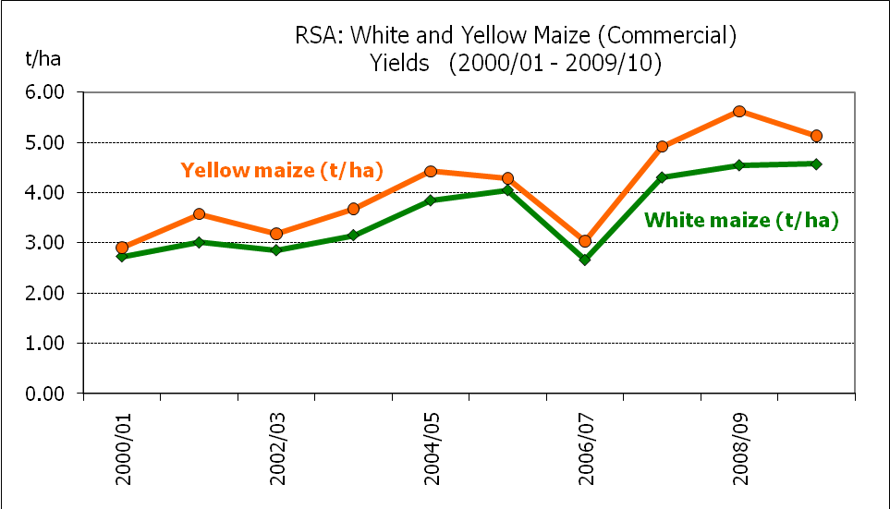

WHITE AND YELLOW MAIZE – AREA PLANTED AND THIRD PRODUCTION FORECAST: 2009/10 PRODUCTION SEASON

WIT- EN GEELMIELIES – OPPERVLAKTE- EN DERDE PRODUKSIESKATTING: 2009/10-PRODUKSIESEISOEN

Provinsie/  Province | Area planted/  Oppervlakte beplant  2009/10 |  |  | 3rd forecast/  3e skatting  2009/10 |  |  | Area planted/  Oppervlakte beplant  2008/09 |  |  | Final crop/  Finale oes  2008/09
 | White/  Wit  Ha | Yellow/  Geel  Ha | Total/  Totaal  Ha | White/  Wit  Tons | Yellow/  Geel  Tons | Total/  Totaal  Tons | White/  Wit  Ha | Yellow/  Geel  Ha | Total/  Totaal  Ha | White/  Wit  Tons | Yellow/  Geel  Tons | Total/  Totaal  Tons
Western Cape/Wes-Kaap | 500 | 2 000 | 2 500 | 3 500 | 16 000 | 19 500 | 1 500 | 3 500 | 5 000 | 15 000 | 35 000 | 50 000
Northern Cape/Noord-Kaap | 2 000 | 51 000 | 53 000 | 23 000 | 599 250 | 622 250 | 2 500 | 48 000 | 50 500 | 28 750 | 605 000 | 633 750
Free State/Vrystaat | 690 000 | 466 000 | 1 156 000 | 3 208 500 | 2 050 400 | 5 258 900 | 565 000 | 390 000 | 955 000 | 2 627 250 | 1 900 000 | 4 527 250
Eastern Cape/Oos-Kaap | 3 200 | 13 200 | 16 400 | 14 400 | 66 000 | 80 400 | 3 000 | 13 000 | 16 000 | 15 900 | 76 500 | 92 400
KwaZulu-Natal | 46 000 | 42 000 | 88 000 | 273 700 | 258 300 | 532 000 | 40 000 | 42 000 | 82 000 | 248 000 | 273 000 | 521 000
Mpumalanga | 232 000 | 250 000 | 482 000 | 1 368 800 | 1 437 500 | 2 806 300 | 215 000 | 262 000 | 477 000 | 1 290 000 | 1 580 000 | 2 870 000
Limpopo | 26 000 | 18 500 | 44 500 | 123 500 | 83 250 | 206 750 | 33 000 | 15 000 | 48 000 | 171 550 | 75 000 | 246 550
Gauteng | 85 000 | 40 000 | 125 000 | 493 000 | 216 000 | 709 000 | 69 000 | 30 000 | 99 000 | 358 800 | 175 500 | 534 300
North West/Noordwes | 635 000 | 140 000 | 775 000 | 2 349 500 | 518 000 | 2 867 500 | 560 000 | 135 000 | 695 000 | 2 019 750 | 555 000 | 2 574 750
Total/Totaal | 1 719 700 | 1 022 700 | 2 742 400 | 7 857 900 | 5 244 700 | 13 102 600 | 1 489 000 | 938 500 | 2 427 500 | 6 775 000 | 5 275 000 | 12 050 000

SUNFLOWER SEED – AREA PLANTED AND THIRD PRODUCTION FORECAST: 2009/10 PRODUCTION SEASON

SONNEBLOMSAAD – OPPERVLAKTE- EN DERDE PRODUKSIESKATTING: 2009/10 PRODUKSIESEISOEN

Province/  Provinsie | Area planted/  Opp beplant  Ha | 3rd forecast/  3e skatting  Tons | Area planted/  Opp beplant  Ha | Final crop/  Finale oes  Tons
 | 2009/10 | 2009/10 | 2008/09 | 2008/09
Western Cape/Wes-Kaap | 200 | 200 | 700 | 700
Northern Cape/Noord-Kaap | 850 | 1 700 | 500 | 1 000
Free State/Vrystaat | 175 000 | 236 250 | 280 000 | 363 000
Eastern Cape/Oos-Kaap | 150 | 165 | 600 | 780
KwaZulu-Natal | - | - | - | -
Mpumalanga | 8 000 | 11 600 | 27 000 | 37 700
Limpopo | 75 000 | 71 250 | 90 000 | 90 000
Gauteng | 3 500 | 4 900 | 7 000 | 9 820
North West/Noordwes | 135 000 | 175 500 | 230 000 | 298 000
Total/Totaal | 397 700 | 501 565 | 635 800 | 801 000

SOYA-BEANS – AREA PLANTED AND THIRD PRODUCTION FORECAST: 2009/10 PRODUCTION SEASON

SOJABONE – OPPERVLAKTE- EN DERDE PRODUKSIESKATTING: 2009/10 PRODUKSIESEISOEN

Province/  Provinsie | Area planted/  Opp beplant  Ha | 3rd forecast/  3e skatting  Tons | Area planted/  Opp beplant  Ha | Final crop/  Finale oes  Tons
 | 2009/10 | 2009/10 | 2008/09 | 2008/09
Western Cape/Wes-Kaap | - | - | - | -
Northern Cape/Noord-Kaap | 650 | 1 950 | 750 | 2 250
Free State/Vrystaat | 95 000 | 161 500 | 55 000 | 99 000
Eastern Cape/Oos-Kaap | 800 | 1 200 | 800 | 1 600
KwaZulu-Natal | 30 000 | 78 000 | 27 000 | 75 600
Mpumalanga | 145 000 | 246 500 | 125 000 | 262 500
Limpopo | 18 000 | 50 400 | 16 000 | 44 000
Gauteng | 12 000 | 20 400 | 6 700 | 12 525
North West/Noordwes | 10 000 | 28 000 | 6 500 | 18 525
Total/Totaal | 311 450 | 587 950 | 237 750 | 516 000

GROUNDNUTS – AREA PLANTED AND THIRD PRODUCTION FORECAST: 2009/10 PRODUCTION SEASON

GRONDBONE – OPPERVLAKTE- EN DERDE PRODUKSIESKATTING: 2009/10 PRODUKSIESEISOEN

Province/  Provinsie | Area planted/  Opp beplant  Ha | 3rd forecast/  3e skatting  Tons | Area planted/  Opp beplant  Ha | Final crop/  Finale oes  Tons
 | 2009/10 | 2009/10 | 2008/09 | 2008/09
Western Cape/Wes-Kaap | - | - | - | -
Northern Cape/Noord-Kaap | 10 000 | 30 000 | 10 000 | 31 000
Free State/Vrystaat | 25 000 | 36 250 | 21 500 | 33 690
Eastern Cape/Oos-Kaap | - |  | -
KwaZulu-Natal | 200 | 300 | - | -
Mpumalanga | - | - | - | -
Limpopo | 2 200 | 4 620 | 3 000 | 6 750
Gauteng | 50 | 60 | 50 | 60
North West/Noordwes | 20 000 | 28 000 | 20 000 | 28 000
Total/Totaal | 57 450 | 99 230 | 54 550 | 99 500

SORGHUM – AREA PLANTED AND THIRD PRODUCTION FORECAST: 2009/10 PRODUCTION SEASON

SORGHUM – OPPERVLAKTE- EN DERDE PRODUKSIESKATTING: 2009/10 PRODUKSIESEISOEN

Province/  Provinsie | Area planted/  Opp beplant  Ha | 3rd forecast/  3e skatting  Tons | Area planted/  Opp beplant  Ha | Final crop/  Finale oes  Tons
 | 2009/10 | 2009/10 | 2008/09 | 2008/09
Western Cape/Wes-Kaap | - | - | - | -
Northern Cape/Noord-Kaap | 25 | 63 | - | -
Free State/Vrystaat | 50 000 | 150 000 | 55 000 | 170 500
Eastern Cape/Oos-Kaap | - | - | - | -
KwaZulu-Natal | 150 | 420 | 300 | 900
Mpumalanga | 15 000 | 52 500 | 16 500 | 66 000
Limpopo | 15 000 | 41 250 | 8 000 | 23 000
Gauteng | 1 000 | 3 000 | 700 | 2 100
North West/Noordwes | 5 500 | 15 400 | 5 000 | 14 000
Total/Totaal | 86 675 | 262 633 | 85 500 | 276 500

DRY BEANS – AREA PLANTED AND THIRD PRODUCTION FORECAST: 2009/10 PRODUCTION SEASON

DROëBONE – OPPERVLAKTE- EN DERDE PRODUKSIESKATTING: 2009/10 PRODUKSIESEISOEN

Province/  Provinsie | Area planted/  Opp beplant  Ha | 3rd forecast/  3e skatting  Tons | Area planted/  Opp beplant  Ha | Final crop/  Finale oes  Tons
 | 2009/10 | 2009/10 | 2008/09 | 2008/09
Western Cape/Wes-Kaap | 100 | 300 | 100 | 280
Northern Cape/Noord-Kaap | 600 | 1 500 | 100 | 250
Free State/Vrystaat | 16 000 | 16 000 | 18 000 | 28 800
Eastern Cape/Oos-Kaap | 400 | 600 | 200 | 300
KwaZulu-Natal | 3 000 | 4 500 | 3 000 | 4 800
Mpumalanga | 10 500 | 14 700 | 10 500 | 15 750
Limpopo | 5 500 | 11 000 | 4 500 | 6 750
Gauteng | 3 500 | 5 250 | 3 400 | 5 100
North West/Noordwes | 4 500 | 6 300 | 4 000 | 5 000
Total/Totaal | 44 100 | 60 150 | 43 800 | 67 030

THIRD PRODUCTION FORECAST OF SUMMER CROPS/
DERDE PRODUKSIESKATTING VIR SOMERGEWASSE

22 APRIL 2010

Summer field crops – 2009/10 production season  Commercial maize: The size of the expected commercial maize crop has been set at 13,103 million tons, which is higher (1,10%) than the previous forecast of 12,961 million tons. The area estimate for maize is 2,742 mill. ha, with an expected average yield of 4,78 t/ha.  The area estimate for white maize is 1,720 mill. ha, and for yellow maize it is 1,023 mill. ha.  The production forecast of white maize is 7,858 mill. tons, which is 0,92% or 71 900 tons more than the 7,786 mill. tons of the previous forecast. The yield for white maize is 4,57 t/ha as against 4,53 t/ha of the previous forecast. In the case of yellow maize the production forecast is 5,245 mill. tons, which is 1,4% or 70 150 tons more than the 5,175 mill. tons of the previous forecast. The yield for yellow maize is 5,13 t/ha as against 5,06 t/ha of the previous forecast.  Sunflower seed: The production forecast for sunflower seed remained unchanged at 501 565 tons. The estimated area planted to sunflower seed also remained unchanged at 397 700 ha and the yield is 1,26 t/ha.  Other crops: The production forecast for soya-beans also remained unchanged at 587 950 tons, whilst the estimated area planted to soya-beans is 311 450 ha. The expected yield is 1,89 t/ha.  The expected groundnut crop is the same as the previous month, namely 99 230 tons, with the area estimate at 57 450 ha, and an expected yield of 1,73 t/ha.  The production forecast for sorghum is 262 633 tons, which is 3,96% higher than the 252 633 tons of the previous forecast. The area estimate for sorghum remained unchanged at 86 675 ha and the expected yield is 3,03 t/ha as against 2,91 t/ha of the previous forecast.  In the case of dry beans, both the production and area planted figures were adjusted downward. The production forecast for dry beans is now 60 150 tons, which is 2,04% less than the 61 400 tons of the previous forecast. The revised area estimate is 44 100 ha, which is 9,26% less than the 48 600 ha planted for the previous forecast. The expected yield is 1,36 t/ha as against 1,26 t/ha of the previous forecast.  Please note that the fourth production forecast for summer field crops for the 2009/10 production season will be released on 20 May 2010. |  | Somergewasse – 2009/10 produksie-seisoen  Kommersiële mielies: Die grootte van die verwagte kommersiële mielie-oes is op 13,103 milj. ton gestel, wat hoër (1,10%) is as die vorige skatting van 12,961 milj. ton. Die skatting van die oppervlakte onder mielies beloop 2,742 milj. ha, met ’n verwagte gemiddelde opbrengs van 4,78t/ha.  Die oppervlak onder witmielies is 1,720 milj. ha en vir geelmielies is dit 1,023 milj. ha.  Die produksieskatting van witmielies is 7,858 miljoen ton, wat 0,92% of 71 900 ton meer is as die 7,786 miljoen ton van die vorige skatting. Die opbrengs van witmielies is 4,57 t/ha teenoor die 4,53 t/ha van die vorige skatting. In die geval van geelmielies is die produksieskatting 5,245 miljoen ton wat 1,4% of 70 150 ton meer is as die 5,175 miljoen ton van die vorige skatting. Die opbrengs van geelmielies is 5,13 t/ha teenoor die 5,06 t/ha van die vorige skatting.  Sonneblomsaad: Die produksieskatting vir sonneblomsaad is onveranderd gelaat op 501 565 ton. Die geskatte oppervlakte beplant met sonneblomsaad is ook onveranderd gelaat op 397 700 ha en die verwagte opbrengs is 1,26 t/ha.  Ander gewasse: Die produksieskatting van sojabone is ook onveranderd gelaat op 587 950 ton, terwyl die verwagte oppervlakte beplant met sojabone 311 450 ton is. Die verwagte opbrengs is 1,89 t/ha.  Die verwagte grondbone-oes is dieselfde as die vorige maand, naamlik 99 230 ton, met ‘n oppervlakte beplant van 57 450 ha, en ‘n verwagte opbrengs van 1,73 t/ha.  Die produksieskatting van sorghum is 262 633 ton, wat 3,96% hoër is as die 252 633 ton van die vorige skatting. Die oppervlakteskatting vir sorghum is onveranderd gelaat op 86 675 ha en die verwagte opbrengs is 3,03 t/ha teenoor die 2,91 t/ha van die vorige skatting.  In die geval van droëbone is beide die syfers vir produksie en oppervlakte beplant afwaarts aangepas. Die produksieskatting vir droëbone is nou 60 150 ton, wat 2,04% minder is as die 61 400 ton van die vorige skatting. Die hersiene oppervlakte beplant is 44 100 ha, wat 9,26% minder is as die 48 600 ha geplant vir die vorige skatting. Die verwagte opbrengs is 1,36 t/ha teenoor die 1,26 t/ha van die vorige skatting.  Neem asseblief kennis dat die vierde produksieskatting vir somergewasse vir 2009/10 produksieseisoen op 20 Mei 2010 vrygestel sal word.

Information is available on the internet at http://www.daff.gov.za/links/crop estimates or http://www.sagis.org.za, as from 14:30 on the date of the relevant meeting of the Crop Estimates Committee. |  | Inligting is beskikbaar op die internet by http://www.daff.gov.za/links/crop estimates of by http://www.sagis.org.za, vanaf 14:30 op die dag van die toepaslike vergadering van die Oesskattingskomitee.

The non-commercial agricultural sectors’ production estimate for maize for the 2009/10 production season is hereby released. /

Hiermee word die nie-kommersiële landbou-sektor se produksieskatting vir mielies vir die 2009/10 produksie-seisoen vrygestel.

NON-COMMERCIAL MAIZE – AREA PLANTED AND PRODUCTION ESTIMATE: 2009/10 PRODUCTION SEASON

NIE-KOMMERSIëLE MIELIES – OPPERVLAKTE- EN PRODUKSIESKATTING: 2009/10-PRODUKSIESEISOEN

CROP/GEWAS | Area planted/  Opp beplant  2009/10 | Estimate/  Skatting  2009/10 | Area planted/  Opp beplant  2008/09 | Final crop/  Finale oes  2008/09 | Change/  Verandering
 | Ha | Tons | Ha | Tons | %
 | (A) | (B) | (C) | (D) | (B) ÷ (D)
Non-commercial agriculture/Nie-kommersiële landbou:
White maize/Witmielies | 371 861 | 421 969 | 356 276 | 378 576 | +11,46
Yellow maize/Geelmielies | 149 079 | 183 895 | 112 407 | 138 057 | +33,20
Maize/Mielies | 520 940 | 605 864 | 468 683 | 516 633 | +17,27
The area planted to maize in the non-commercial agricultural sector is estimated at 520 940 ha, which represents an increase of 11,1 % compared to the 468 683 ha of the previous season. Due to favourable production conditions, the expected maize crop for this sector is 605 864 tons, which is 17,3 % higher than the 516 633 tons of last season.
Die oppervlakte beplant met mielies in die nie-kommersiële landbou-sektor word geskat op 520 940 ha, wat ‘n toename van 11,1 % verteenwoordig in vergelyking met die 468 683 ha van die vorige seisoen. Weens gunstige produksie toestande, is die verwagte mielie-oes van dié sektor 605 864 ton, wat 17,3 % hoër is as die 516 633 ton van die vorige seisoen.

WINTERGEWASSE – VOORNEME OM TE PLANT: 2010-SEISOEN

WINTER CEREALS –INTENTIONS TO PLANT: 2010 SEASON

GEWAS/CROP | Voorneme/  Intentions*  2010 | Opp beplant/  Area planted  2009 | Finale skatting/  Final estimate  2009 | 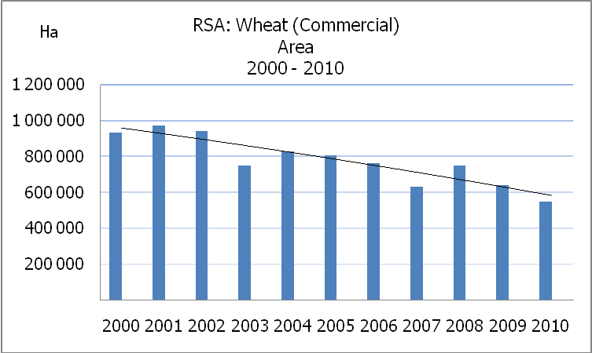Verandering/  Change
 | Ha | Ha | Tons | %
 | (A) | (B) | (C) | (A) ÷ (B)
Koring/Wheat | 548 000 | 642 500 | 1 919 800 | -14,71
Moutgars/Malting barley | 85 000 | 74 760 | 223 622 | +13,70
Kanola/Canola | 37 500 | 35 060 | 40 310 | +6,96
Totaal/Total | 670 500 | 752 320 | 2 183 732 | -10,88

* Based on conditions at the middle of April 2010 / Gebaseer op toestande soos teen middel April 2010.

KORING – VOORNEME OM TE PLANT: 2010-SEISOEN

WHEAT – INTENTIONS TO PLANT: 2010 SEASON

Provinsie/  Province | Voorneme/  Intentions  Ha | Opp beplant/  Area planted  Ha | Finale skatting/  Final estimate  Tons
 | 2010 | 2009 | 2009
Wes-Kaap/Western Cape | 277 000 | 300 000 | 675 000
Noord-Kaap/Northern Cape | 38 000 | 44 000 | 277 200
Vrystaat/Free State | 180 000 | 235 000 | 622 750
Oos-Kaap/Eastern Cape | 4 200 | 5 000 | 20 000
KwaZulu-Natal | 6 000 | 7 000 | 35 000
Mpumalanga | 5 000 | 7 500 | 41 250
Limpopo | 14 000 | 18 000 | 99 000
Gauteng | 1 800 | 2 000 | 12 800
Noordwes/North West | 22 000 | 24 000 | 136 800
Totaal/Total | 548 000 | 642 500 | 1 919 800

* Based on conditions at the middle of April 2010 / Gebaseer op toestande soos teen middel April 2010.

INTENTIONS TO PLANT WINTER CROPS FOR 2010 / VOORNEME OM WINTERGEWASSE AAN TE PLANT VIR 2010

22 April 2010

Winter cereal crops – 2010 production season  The intentions to plant are based on inputs as at the middle of April 2010, received from:  - Department of Agriculture, Forestry and Fisheries: Sample of producers; and  - Provincial Departments of Agriculture: PDA representatives.  The figures for wheat represent the total number of hectares that are intended to be planted for grain, excluding any hectares that will be planted for fodder and grazing.  Early indications are that producers intend to plant 548 000 ha of wheat for the 2010 production season. This is 94 500 ha or 14,7% less than the area planted to wheat in 2009. This is also the smallest area planted to wheat since the early 1900’s. The main producing areas are within the Western Cape with 277 000 ha (51%), followed by the Free State with 180 000 ha (33%) and the Northern Cape with 38 000 ha (7%).  According to producers the decrease in the expected planting of wheat can mainly be attributed to unfavourable prices for the crop.  The expected area planted to malting barley is 85 000 ha, which shows an increase of 10 240 ha compared to the 74 760 ha of the previous year. The expected area planted to canola is 37 500 ha, which is 2 440 ha more than the 35 060 ha planted in 2009.  Please note that the preliminary area estimate of winter crops for 2010 will be released on 22 July 2010. |  | Wintergewasse – 2010 produksie-seisoen  Die voorneme om te plant is gebaseer op insette soos teen die middel van April 2010, ontvang van:  - Departement van Landbou, Bosbou en Visserye: Steekproef van produsente; en  - Provinsiale Departemente van Landbou: PDL Verteenwoordigers.  Die syfers vir koring verteenwoordig die totale aantal hektare wat werklik beplant gaan word vir graan, uitgesluit alle hektare wat beplant gaan word vir groenvoer en weiding.  Vroeë aanduidings is dat produsente van voorneme is om 548 000 ha koring te plant vir die 2010-produksie-seisoen. Dit is 94 500 ha of 14,7% minder koring as in 2009. Dit is ook die kleinste oppervlakte beplant met koring sedert die vroeë 1900’s. Die grootste produserende gebiede is in die Wes-Kaap, met 277 000 ha (51%), gevolg deur die Vrystaat met 180 000 ha (33%) en die Noord-Kaap met 38 000 ha (7%).  Volgens produsente kan die afname in verwagte aanplantings van koring hoofsaaklik toegeskryf word aan ongunstige pryse vir dié gewas.  Die verwagte aanplantings van moutgars is 85 000 ha wat ‘n toename van 10 240 ha toon in vergelyking met die 74 760 ha van die vorige jaar. Die verwagte aanplantings van kanola is 37 500 ha wat 2 440 ha meer is as die 35 060 ha wat aangeplant was in 2009.  Neem asseblief kennis dat die voorlopige oppervlakteskatting vir wintergewasse vir 2010 op 22 Julie 2010 vrygestel sal word.
Information is available on the internet at http://www.daff.gov.za/links/crop estimates or http://www.sagis.org.za, as from 14:30 on the date of the relevant meeting of the Crop Estimates Committee. |  | Inligting is beskikbaar op die internet by http://www.daff.gov.za/links/crop estimates of by http://www.sagis.org.za, vanaf 14:30 op die dag van die toepaslike vergadering van die Oesskattingskomitee.

