 | crop estimates committee | 
 | oesskattingskomitee
From/Van: Mr Baldwin Netshifhefhe
Tel: 012 319 8043  Fax/Faks: 012 319 8031  E-mail/E-pos: BaldwinN@daff.gov.za
Web page/Webblad: www.daff.gov.za/statistics and economic reports or www.sagis.org.za/CEC: Crop Estimates
EMBARGO: 14:30

19 December/Desember 2019

The area estimate and fifth production forecast for winter cereals for the 2019 is hereby released. /

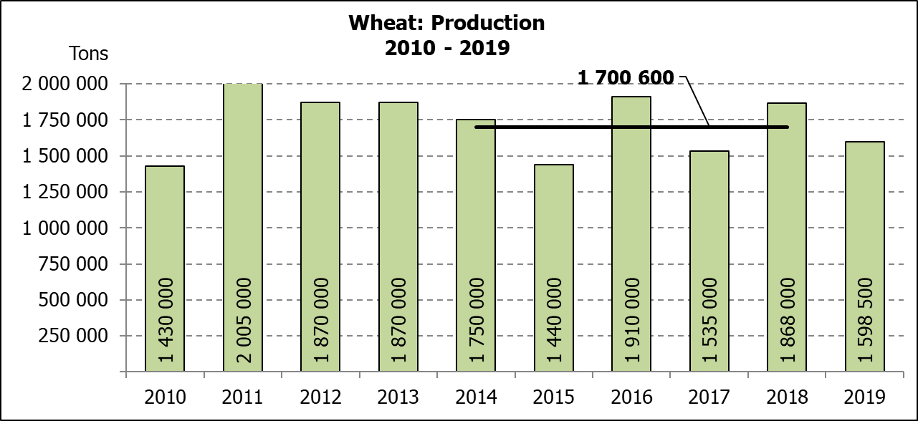Hiermee word die oppervlakte- en vyfde produksieskatting vir wintergewasse vir 2019 vrygestel.

WINTER CEREALS – AREA PLANTED AND FIFTH PRODUCTION FORECAST: 2019 PRODUCTION SEASON

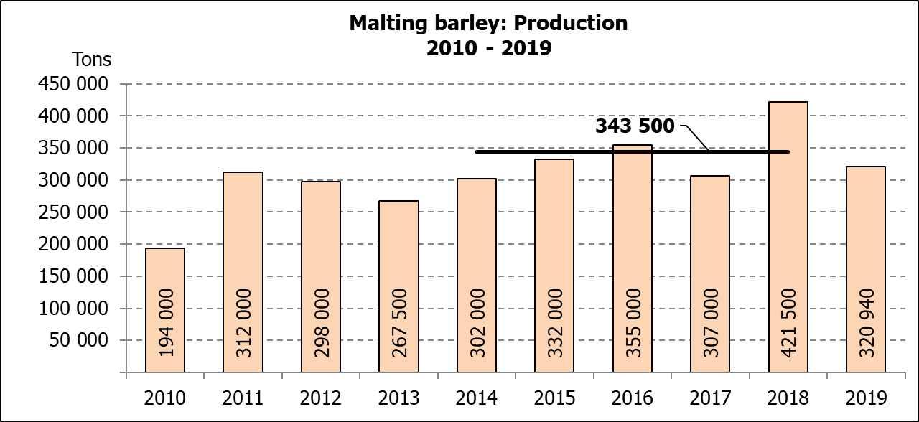WINTERGEWASSE – OPPERVLAKTE- EN VYFDE PRODUKSIESKATTING: 2019-PRODUKSIESEISOEN

CROP/GEWAS | Area planted/  Opp beplant  2019 | 5th forecast/  5de skatting  2019 | 4th forecast/  4de skatting  2019 | Area planted/  Opp beplant  2018 | Final crop/  Finale oes  2018 | Change/  Verandering
 | Ha | Tons | Tons | Ha | Tons | %
 | (A) | (B) | (C) | (D) | (E) | (B) ÷ (C)
Commercial/Kommersieel:
Wheat/Koring | 540 000 | 1 598 500 | 1 618 460 | 503 350 | 1 868 000 | -1,23
Malting barley/Moutgars | 131 960 | 320 940 | 358 760 | 119 000 | 421 500 | -10,54
Canola/Kanola | 74 000 | 96 200 | 96 200 | 77 000 | 104 500 | -
Cereal oats/Hawermout | 27 200 | 27 490 | 31 240 | 19 235 | 32 700 | -12,00

* Note: Estimate is for calendar year, e.g. production season 2019/20 = 2019

* Nota: Skatting is vir kalenderjaar, bv. produksie-seisoen 2019/20 = 2019

WHEAT – AREA PLANTED AND FIFTH PRODUCTION FORECAST: 2019

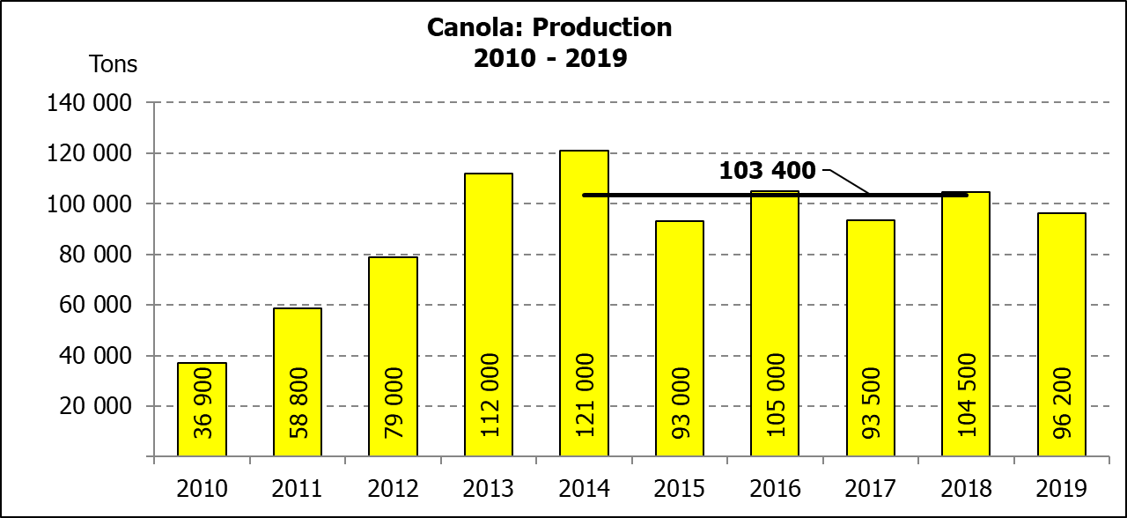KORING – OPPERVLAKTE- EN VYFDE PRODUKSIESKATTING: 2019

Province/  Provinsie | Area planted/  Opp beplant  Ha | 5th forecast/  5de skatting Tons | Area planted/  Opp beplant  Ha | Final crop/  Finale oes  Tons
 | 2019 | 2019 | 2018 | 2018
Western Cape/Wes-Kaap | 325 000 | 666 250 | 318 000 | 890 500
Northern Cape/Noord-Kaap | 37 500 | 270 000 | 38 000 | 294 500
Free State/Vrystaat | 128 000 | 358 400 | 100 000 | 385 000
Eastern Cape/Oos-Kaap | 3 100 | 15 500 | 1 650 | 10 730
KwaZulu-Natal | 7 500 | 45 750 | 7 000 | 43 400
Mpumalanga | 4 000 | 25 200 | 3 500 | 22 740
Limpopo | 20 000 | 128 000 | 20 000 | 128 000
Gauteng | 1 400 | 8 400 | 1 200 | 7 800
North West/Noordwes | 13 500 | 81 000 | 14 000 | 85 330
Total/Totaal | 540 000 | 1 598 500 | 503 350 | 1 868 000

AREA ESTIMATE AND FIFTH PRODUCTION FORECAST OF WINTER CROPS (2019) /
OPPERVLAKTEKSKATTING EN VYFDE PRODUKSIESKATTING VAN WINTERGEWASSE (2019)

19 DECEMBER/DESEMBER 2019

Winter cereal crops - 2019 production season  Wheat: The expected production of wheat is 1,598 mill. tons, which is 1,23% or 19 960 tons less than the previous forecast of 1,618 mill. tons, whilst the expected yield is 2,96 t/ha.  The expected production in the Western Cape is 666 250 tons (42%), in the Free State 358 400 tons (22%) and in the Northern Cape 270 000 tons (17%).  An estimated 325 000 ha or 60% is planted in the Western Cape, 128 000 ha or 24% in the Free State and 37 500 ha or 7% in the Northern Cape.  Other crops: The production forecast for malting barley is 320 940 tons, which is 10,54% or 37 820 tons less than the previous forecast of 358 760 tons. The area planted is estimated at 131 960 ha, whilst the expected yield is 2,43 t/ha.  The expected canola crop remained unchanged at 96 200 tons. The area estimate for canola is 74 000 ha, with an expected yield of 1,30 t/ha.  The area estimate for oats (cereals) for the 2019 season is 27 200 ha and the expected crop is 27 490 tons. The expected yield is 1,01 t/ha.  Please note that the sixth production forecast for winter cereals (2019) and the preliminary area planted estimate for summer grains (2020) will be released on 29 January 2020. |  | Wintergewasse - 2019 produksie-seisoen  Koring: Die verwagte produksie vir koring is 1,598 milj. ton, wat 1,23% of 19 960 ton minder is as die vorige skatting van 1,618 milj. ton, terwyl die verwagte opbrengs 2,96 t/ha is.  Die verwagte produksie in die Wes-Kaap is 666 250 ton (42%), in die Vrystaat 358 400 ton (22%) en in die Noord-Kaap 270 000 ton (17%).  Die beraamde oppervlakte geplant in die Wes-Kaap is 325 000 ha of 60%, die Vrystaat is 128 000 ha of 24% en 37 500 ha of 7% is in die Noord-Kaap.  Ander gewasse: Die produksieskatting vir moutgars is 320 940 ton, wat 10,54% of 37 820 ton minder is as die vorige skatting van 358 760 ton. Die oppervlakte beplant word beraam op 131 960 ha, terwyl die verwagte opbrengs 2,43 t/ha beloop.  Die verwagte kanola-oes is onveranderd gelaat op 96 200 ton. Die oppervlakteskatting vir kanola is 74 000 ha, met ŉ verwagte opbrengs van 1,30 t/ha.  Die oppervlakteskatting vir hawer (ontbytgraan) vir die 2019-seisoen is 27 200 ha en die verwagte oes is 27 490 ton. Die verwagte opbrengs is 1,01 t/ha.  Neem asseblief kennis dat die sesde produksieskatting vir wintergewasse (2019) en die voorlopige oppervlakteskatting vir somergewasse (2020) op 29 Januarie 2020 vrygestel sal word.

Information is available on the internet at http://www.daff.gov.za/links/crop estimates or http://www.sagis.org.za, as from 14:30 on the date of the relevant meeting of the Crop Estimates Committee. |  | Inligting is beskikbaar op die internet by http://www.daff.gov.za/links/crop estimates of by http://www.sagis.org.za, vanaf 14:30 op die dag van die toepaslike vergadering van die Oesskattingskomitee.

