 | crop estimates committee | 
 | oesskattingskomitee
From/Van: Rodney D. Dredge
Tel: 012 319 6507  Fax/Faks: 012 319 6211  E-mail/E-pos: CDESS@daff.gov.za
Web page/Webblad: www.daff.gov.za/crop estimates or www.sagis.org.za/CEC: Crop Estimates
EMBARGO: 14:30

The sixth production forecast for summer crops for the 2009/10 production season is hereby released. /

Hiermee word die sesde produksieskatting vir somergewasse vir die 2009/10 produksie-seisoen vrygestel.

SUMMER CROPS – AREA PLANTED AND SIXTH PRODUCTION FORECAST: 2009/10 PRODUCTION SEASON

SOMERGEWASSE – OPPERVLAKTE- EN SESDE PRODUKSIESKATTING: 2009/10-PRODUKSIESEISOEN

CROP/GEWAS | Area planted/  Opp beplant  2009/10 | 6th forecast/  6e skatting  2009/10 | 5th forecast/  5e skatting  2009/10 | Area planted/  Opp beplant  2008/09 | Finale oes/  Final crop  2008/09 | Change/  Verande-ring
 | Ha | Tons | Tons | Ha | Tons | %
 | (A) | (B) | (C) | (D) | (E) | (B) ÷ (C)
Commercial/Kommersieël:
White maize/Witmielies | 1 719 700 | 7 999 250 | 7 999 250 | 1 489 000 | 6 775 000 | -
Yellow maize/Geelmielies | 1 022 700 | 5 317 800 | 5 317 800 | 938 500 | 5 275 000 | -
Maize/Mielies | 2 742 400 | 13 317 050 | 13 317 050 | 2 427 500 | 12 050 000 | -
Sunflower seed/Sunflower seed | 397 700 | 528 765 | 528 765 | 635 800 | 801 000 | -
Soya-beans/Sojabone | 311 450 | 567 200 | 567 200 | 237 750 | 516 000 | -
Groundnuts/Grondbone | 57 450 | 87 880 | 87 880 | 54 550 | 99 500 | -
Sorghum | 86 675 | 241 593 | 241 593 | 85 500 | 276 500 | -
Dry beans/Droëbone | 44 100 | 52 255 | 52 255 | 43 800 | 67 030 | -
TOTAL/TOTAAL | 3 639 775 | 14 794 743 | 14 794 743 | 3 484 900 | 13 810 030 | -

22 July/Julie 2010

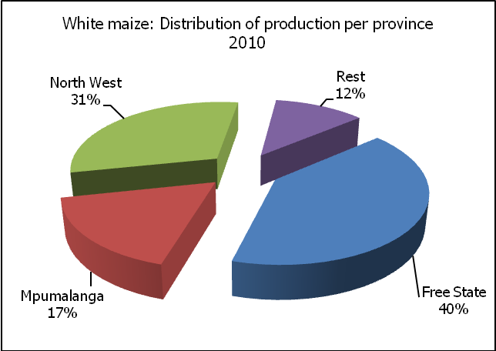

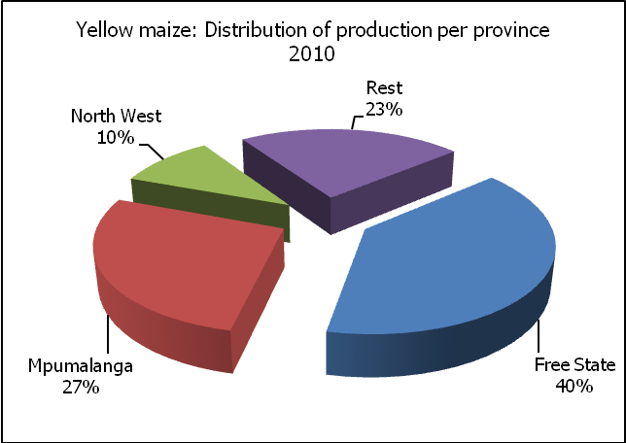

WHITE AND YELLOW MAIZE – AREA PLANTED AND SIXTH PRODUCTION FORECAST: 2009/10 PRODUCTION SEASON

WIT- EN GEELMIELIES – OPPERVLAKTE- EN SESDE PRODUKSIESKATTING: 2009/10-PRODUKSIESEISOEN

Provinsie/  Province | Area planted/  Oppervlakte beplant  2009/10 |  |  | 6th forecast/  6e skatting  2009/10 |  |  | Area planted/  Oppervlakte beplant  2008/09 |  |  | Final crop/  Finale oes  2008/09
 | White/  Wit  Ha | Yellow/  Geel  Ha | Total/  Totaal  Ha | White/  Wit  Tons | Yellow/  Geel  Tons | Total/  Totaal  Tons | White/  Wit  Ha | Yellow/  Geel  Ha | Total/  Totaal  Ha | White/  Wit  Tons | Yellow/  Geel  Tons | Total/  Totaal  Tons
Western Cape/Wes-Kaap | 500 | 2 000 | 2 500 | 3 500 | 16 000 | 19 500 | 1 500 | 3 500 | 5 000 | 15 000 | 35 000 | 50 000
Northern Cape/Noord-Kaap | 2 000 | 51 000 | 53 000 | 23 000 | 599 250 | 622 250 | 2 500 | 48 000 | 50 500 | 28 750 | 605 000 | 633 750
Free State/Vrystaat | 690 000 | 466 000 | 1 156 000 | 3 243 000 | 2 097 000 | 5 340 000 | 565 000 | 390 000 | 955 000 | 2 627 250 | 1 900 000 | 4 527 250
Eastern Cape/Oos-Kaap | 3 200 | 13 200 | 16 400 | 14 400 | 66 000 | 80 400 | 3 000 | 13 000 | 16 000 | 15 900 | 76 500 | 92 400
KwaZulu-Natal | 46 000 | 42 000 | 88 000 | 273 700 | 258 300 | 532 000 | 40 000 | 42 000 | 82 000 | 248 000 | 273 000 | 521 000
Mpumalanga | 232 000 | 250 000 | 482 000 | 1 380 400 | 1 450 000 | 2 830 400 | 215 000 | 262 000 | 477 000 | 1 290 000 | 1 580 000 | 2 870 000
Limpopo | 26 000 | 18 500 | 44 500 | 123 500 | 83 250 | 206 750 | 33 000 | 15 000 | 48 000 | 171 550 | 75 000 | 246 550
Gauteng | 85 000 | 40 000 | 125 000 | 493 000 | 216 000 | 709 000 | 69 000 | 30 000 | 99 000 | 358 800 | 175 500 | 534 300
North West/Noordwes | 635 000 | 140 000 | 775 000 | 2 444 750 | 532 000 | 2 976 750 | 560 000 | 135 000 | 695 000 | 2 019 750 | 555 000 | 2 574 750
Total/Totaal | 1 719 700 | 1 022 700 | 2 742 400 | 7 999 250 | 5 317 800 | 13 317 050 | 1 489 000 | 938 500 | 2 427 500 | 6 775 000 | 5 275 000 | 12 050 000

SUNFLOWER SEED – AREA PLANTED AND SIXTH PRODUCTION FORECAST: 2009/10 PRODUCTION SEASON

SONNEBLOMSAAD – OPPERVLAKTE- EN SESDE PRODUKSIESKATTING: 2009/10 PRODUKSIESEISOEN

Province/  Provinsie | Area planted/  Opp beplant  Ha | 6th forecast/  6e skatting  Tons | Area planted/  Opp beplant  Ha | Final crop/  Finale oes  Tons
 | 2009/10 | 2009/10 | 2008/09 | 2008/09
Western Cape/Wes-Kaap | 200 | 200 | 700 | 700
Northern Cape/Noord-Kaap | 850 | 1 700 | 500 | 1 000
Free State/Vrystaat | 175 000 | 245 000 | 280 000 | 363 000
Eastern Cape/Oos-Kaap | 150 | 165 | 600 | 780
KwaZulu-Natal | - | - | - | -
Mpumalanga | 8 000 | 12 800 | 27 000 | 37 700
Limpopo | 75 000 | 75 000 | 90 000 | 90 000
Gauteng | 3 500 | 4 900 | 7 000 | 9 820
North West/Noordwes | 135 000 | 189 000 | 230 000 | 298 000
Total/Totaal | 397 700 | 528 765 | 635 800 | 801 000

SOYA-BEANS – AREA PLANTED AND SIXTH PRODUCTION FORECAST: 2009/10 PRODUCTION SEASON

SOJABONE – OPPERVLAKTE- EN SESDE PRODUKSIESKATTING: 2009/10 PRODUKSIESEISOEN

Province/  Provinsie | Area planted/  Opp beplant  Ha | 6th forecast/  6e skatting  Tons | Area planted/  Opp beplant  Ha | Final crop/  Finale oes  Tons
 | 2009/10 | 2009/10 | 2008/09 | 2008/09
Western Cape/Wes-Kaap | - | - | - | -
Northern Cape/Noord-Kaap | 650 | 1 950 | 750 | 2 250
Free State/Vrystaat | 95 000 | 152 000 | 55 000 | 99 000
Eastern Cape/Oos-Kaap | 800 | 1 200 | 800 | 1 600
KwaZulu-Natal | 30 000 | 75 000 | 27 000 | 75 600
Mpumalanga | 145 000 | 239 250 | 125 000 | 262 500
Limpopo | 18 000 | 50 400 | 16 000 | 44 000
Gauteng | 12 000 | 20 400 | 6 700 | 12 525
North West/Noordwes | 10 000 | 27 000 | 6 500 | 18 525
Total/Totaal | 311 450 | 567 200 | 237 750 | 516 000

GROUNDNUTS – AREA PLANTED AND SIXTH PRODUCTION FORECAST: 2009/10 PRODUCTION SEASON

GRONDBONE – OPPERVLAKTE- EN SESDE PRODUKSIESKATTING: 2009/10 PRODUKSIESEISOEN

Province/  Provinsie | Area planted/  Opp beplant  Ha | 6th forecast/  6e skatting  Tons | Area planted/  Opp beplant  Ha | Final crop/  Finale oes  Tons
 | 2009/10 | 2009/10 | 2008/09 | 2008/09
Western Cape/Wes-Kaap | - | - | - | -
Northern Cape/Noord-Kaap | 10 000 | 27 000 | 10 000 | 31 000
Free State/Vrystaat | 25 000 | 35 000 | 21 500 | 33 690
Eastern Cape/Oos-Kaap | - |  | -
KwaZulu-Natal | 200 | 300 | - | -
Mpumalanga | - | - | - | -
Limpopo | 2 200 | 3 520 | 3 000 | 6 750
Gauteng | 50 | 60 | 50 | 60
North West/Noordwes | 20 000 | 22 000 | 20 000 | 28 000
Total/Totaal | 57 450 | 87 880 | 54 550 | 99 500

SORGHUM – AREA PLANTED AND SIXTH PRODUCTION FORECAST: 2009/10 PRODUCTION SEASON

SORGHUM – OPPERVLAKTE- EN SESDE PRODUKSIESKATTING: 2009/10 PRODUKSIESEISOEN

Province/  Provinsie | Area planted/  Opp beplant  Ha | 6th forecast/  6e skatting  Tons | Area planted/  Opp beplant  Ha | Final crop/  Finale oes  Tons
 | 2009/10 | 2009/10 | 2008/09 | 2008/09
Western Cape/Wes-Kaap | - | - | - | -
Northern Cape/Noord-Kaap | 25 | 63 | - | -
Free State/Vrystaat | 50 000 | 130 000 | 55 000 | 170 500
Eastern Cape/Oos-Kaap | - | - | - | -
KwaZulu-Natal | 150 | 480 | 300 | 900
Mpumalanga | 15 000 | 52 500 | 16 500 | 66 000
Limpopo | 15 000 | 41 250 | 8 000 | 23 000
Gauteng | 1 000 | 3 000 | 700 | 2 100
North West/Noordwes | 5 500 | 14 300 | 5 000 | 14 000
Total/Totaal | 86 675 | 241 593 | 85 500 | 276 500

DRY BEANS – AREA PLANTED AND SIXTH PRODUCTION FORECAST: 2009/10 PRODUCTION SEASON

DROëBONE – OPPERVLAKTE- EN SESDE PRODUKSIESKATTING: 2009/10 PRODUKSIESEISOEN

Province/  Provinsie | Area planted/  Opp beplant  Ha | 6th forecast/  6e skatting  Tons | Area planted/  Opp beplant  Ha | Final crop/  Finale oes  Tons
 | 2009/10 | 2009/10 | 2008/09 | 2008/09
Western Cape/Wes-Kaap | 100 | 300 | 100 | 280
Northern Cape/Noord-Kaap | 600 | 1 200 | 100 | 250
Free State/Vrystaat | 16 000 | 14 400 | 18 000 | 28 800
Eastern Cape/Oos-Kaap | 400 | 480 | 200 | 300
KwaZulu-Natal | 3 000 | 4 500 | 3 000 | 4 800
Mpumalanga | 10 500 | 12 075 | 10 500 | 15 750
Limpopo | 5 500 | 9 350 | 4 500 | 6 750
Gauteng | 3 500 | 4 550 | 3 400 | 5 100
North West/Noordwes | 4 500 | 5 400 | 4 000 | 5 000
Total/Totaal | 44 100 | 52 255 | 43 800 | 67 030

